CANBURY SCHOOL

CHILD SAFEGUARDING POLICY
AND PROCEDURES

December 2016
Last review and update: August 2020

CHILD SAFEGUARDING POLICY AND PROCEDURES

Table of Contents
- Policy Statement……………………………………………………………………………
- Key Personnel and Contacts………………………………………………………………..
- Roles and responsibilities…………………………………………...………………………
  - Designated Safeguarding Leads in School…………………...………………………..

  - The Deputy DSL…………………………………………......………………………..

  - The Headmistress…………………………………………......…..……………………..

  - All Canbury School Staff, Supply Staff and volunteers …………………….…………

  - The Governing Board…………….…………….....…..………………….....

- Confidentiality

5. Definitions and Terminology…………………….…………….....…..………………….....
6. Equalities
7. What is child abuse? …………………….………………….….....…..……………………

7a Physical Abuse ...…………………….………………….….....…..……………..……..

7b Emotional Abuse .....………………….……………….….....…..……………………..

7c Sexual Abuse .....……...……………….……………….….....…..……………………..

7d Neglect .....……...……………….……………….….....………...……………………..

8. Recognising abuse and taking action.....……...……..……….….....………...…………

8a What should staff do if they have a concern about a child…………………………....

8b Early Help……………………………………………………………………………

8c What should staff do if a child is in danger or at risk of harm………………………...

8d Action where a child has serious injuries which require immediate treatment...…….…..

8e Action if you have concerns about extremism…………………………………………

8f If you have a mental health concern………………………………………………

8g Actions if you have concerns around Female Genital Mutilation (FGM)………….

8h If you suspect or become aware of an allegation of abuse (including peer on peer/child on child abuse, sexual violence or sexual harassment)……………………………………

8i Sexting……………………………………………………………………………..

8j What should staff do if they have concerns about another staff member, supply or volunteer

8k What should staff do if they have concerns about the head teacher………………..

8l What should staff do if they have concerns about safeguarding practices within the school…………………………………………………………………………………

9. Disclosure ……………………………………………………………………………

10. Action by the DSL.....……...……..………................…………...………..……………..

11. Contacting parents ....……...……..………................…………...………..……………..

12. Children with special educational needs and disabilities………………………………..

13. Use of reasonable force………………………………………………………………..

14. Students with a social worker…………………………………………………………..

15. Looked-after or previously looked-after children………………………………………..

- Training ....……………...……..……….….............................………...…………………

- Complaints and concerns about school safeguarding policies....……………...……..…

- Whistle-blowing....……………...……..………......………...………………………….

- Record-keeping

- Review and Monitoring .....……………...……..………......………...…………………

Appendix A – Taking Action .....……………...…………...………...……………………..

Appendix B: Actions where there are concerns about a child.....……………...…………...

Appendix C – Procedure to be followed in the event of a disclosure……..………………..

Appendix D – Procedure for reporting a concern……..…………………………………..

Appendix E – Allegation of abuse by a member of school staff, supply or volunteer (teaching or non-teaching) ……..…………………………………………………………………..…........................

Appendix F - Referral procedure for when a child/young person discloses to a member of school staff an allegation of abuse by a Headteacher……..…………………………...…........................................

Appendix G – Procedure for referring a concern to CHANNEL……..………………......................

Appendix H - Allegations of abuse made against staff……..………………...........................................

Appendix I - Specific safeguarding issues ………………………………………………………...…

Appendix J: Checking the identity and suitability of visitors……………………………………...…..

Appendix K: Non-collection of children and Missing Students………………………………………

Appendix J: Safer Recruitment……..…………………………...…...........................................................

1 Policy Statement
Canbury School is committed to safeguarding, defined as: protecting children from maltreatment; preventing impairment of children’s health or development; ensuring that children grow up in circumstances consistent with the provision of safe and effective care; and taking action to enable all children to have the best outcomes. The welfare of our children is paramount. All children, regardless of age, gender, culture, language, race, ability, sexual identity or religion have equal rights to protection, safeguarding and opportunities.

We expect all staff and volunteers to share this commitment. We have a very important responsibility and duty regarding child protection. We aim to make school a place where all students feel secure and supported and where they are confident that they will be listened to should the need arise. All staff and volunteers should consider, at all times, what is in the best interests of the child.

This policy is based on the Department for Education’s statutory guidance Keeping Children Safe in Education (2020) and Working Together to Safeguard Children (2018), and the Governance Handbook. We comply with this guidance and the arrangements agreed and published by our local safeguarding partners.

This policy is also based on the following legislation:
- Part 3 of the schedule to the Education (Independent School Standards) Regulations 2014, which places a duty on academies and independent schools to safeguard and promote the welfare of pupils at the school
- The Children Act 1989 (and 2004 amendment), which provides a framework for the care and protection of children
- Section 5B(11) of the Female Genital Mutilation Act 2003, as inserted by section 74 of the Serious Crime Act 2015, which places a statutory duty on teachers to report to the police where they discover that female genital mutilation (FGM) appears to have been carried out on a girl under 18
- Statutory guidance on FGM, which sets out responsibilities with regards to safeguarding and supporting girls affected by FGM
- The Rehabilitation of Offenders Act 1974, which outlines when people with criminal convictions can work with children
- Schedule 4 of the Safeguarding Vulnerable Groups Act 2006, which defines what ‘regulated activity’ is in relation to children
- London Child Protection Procedures and Practice Guidance

- Statutory guidance on the Prevent duty, which explains schools’ duties under the Counter-Terrorism and Security Act 2015 with respect to protecting people from the risk of radicalisation and extremism

The policy has also been written with regard to the Kingston and Richmond Safeguarding Children Partnership guidance.

Adherence to the School’s Child Safeguarding policy is mandatory for all staff, supply staff
and volunteers and its use is not subject to discretion. All staff must, therefore, be aware
of child protection issues, and the procedures set out in this document.

The School is committed to keeping all students safe, healthy and equipped to deal with dangers
presented in their daily lives. Staff raise students’ awareness through various pastoral and curriculum activities, including Personal and Social Education, Health Education, Academic and Personal Tutoring, and thus develop a trusting climate where students are able to develop their understanding of staying safe and talk and share their thoughts and feelings.

Canbury School seeks to implement this policy through adherence to the procedures set out in the rest of this document.

This document is reviewed annually by Louise Clancy (Headmistress), Philippa Rich (Assistant Head – Pastoral) and by our Governing Body. The next scheduled date for reviews is August 2021.

2 Key Personnel and Contacts
An effective whole school child protection policy is one which provides clear direction to staff
and others about expected codes of behaviour in dealing with child protection issues. An
effective policy also makes explicit the School’s commitment to the development of good
practice and sound procedures. This ensures that child protection concerns and referrals may
be handled sensitively, professionally and in ways which prioritise the needs of the child.

The Headmistress and Deputy Safeguarding Lead:
Ms Louise Clancy
Email: lclancy@canburyschool.co.uk
Phone number: 020 8549 8622

Deputy Safeguarding Lead:
Ms Louise Boggi
Email: lboggi@canburyschool.co.uk
Phone number: 020 8549 8622

The nominated Local Governing Body member with oversight of safeguarding issues
Mandy Beck
Email: safeguardinggovernor@canburyschool.co.uk

The Designated Safeguarding Lead:
Mrs Philippa Rich
Email: prich@canburyschool.co.uk
Phone number: 020 8549 8622

Local Authority Safeguarding Boards
Kingston and Richmond Safeguarding Children Partnership is Canbury School’s Local Safeguarding Children’s Board. It provides emergency duty social services for children, young people and their families jointly with neighbouring London boroughs.

Kingston Single Point of Access (SPA)
Phone: 020 8547 5008 (Monday to Thursday, 8.45am-5.00pm, Friday 8.45am-4.45pm)
Out of hours emergency - Duty Team Telephone number: 020 8770 5000
Email: SPA@rbk.kingston.gov.uk

LADO (Local Authority Designated Officer) is Amanda Burrows
Direct Line: 07774 332675 / 0208 891 7370
LADO@achievingforchildren.org.uk
The LADO provides advice and presides over the investigation of any allegation or suspicion of
abuse directed against anyone working in the school.

However, if you are seriously concerned about a child's immediate safety, always dial 999.
Full local procedures on what to do if you have a concern are available at
http://www.kingston.gov.uk/info/200235/safeguarding_children

Child Sexual Exploitation (CSE) officer for Kingston Police:
Gregory Day | Police Constable 119VK | Met 713571
Telephone 02032763571
Email: VK-PPD@met.pnn.police.uk
Address: MASH,
Guildhall 2,
The High St,
Kingston Upon Thames,
Surrey
KT1 1EU

PREVENT lead Kingston - Stephanie.royston-mitchell@kingston.gov.uk
PREVENT Team - prevent@kingston.gov.uk

Kingston Schools Liaison Officer
PC David Evans
Email: David.E.Evans@met.police.uk

The following links provide information about safeguarding:
- www.childline.org.uk - Childline is the free helpline for children and young people in the UK. Children and young people can call 0800 1111 to talk about any problem
- www.education.gov.uk - Department for Education
- www.nspcc.org.uk - The NSPCC (National Society for the Prevention of Cruelty to Children) is the UK's leading charity specialising in child protection and the prevention of cruelty to children.
- www.barnardos.org.uk - Helps the most vulnerable children and young people transform their lives and fulfil their potential.

This policy should be considered alongside other related policies in school. These are:
1. Anti-Bullying Policy (includes Cyberbullying)
2. Prevent and Upholding British Values Policy
3. Special Educational Needs and Disabilities Policy
4. Health and Safety Policy
5. Equal Opportunities Policy
6. Student Behaviour, Sanctions and Rewards Policy
7. Whistle-blowing Policy
8. Safer Recruitment Policy
9. Acceptable Use of ICT Policy (includes taking and storing images)
10. Educational Visits Policy
11. Social Media Policy
12. Staff Code of Conduct
13. Mental Health Procedures
14. Looked after child Policy
15. Suicide Procedure
16. Children missing education Policy

3 Roles and responsibilities

3.1 Designated Safeguarding Leads in School
The Designated Safeguarding Lead (DSL), Philippa Rich, has overall responsibility for the implementation of procedures and liaison with Children’s Social Care Services and other agencies on behalf of the School, in consultation with the Headmistress of Canbury School.

During term time the Designated Safeguarding Lead (or a Deputy) should always be available (during school hours) for staff in the school to discuss any safeguarding concerns, whether that is face-to-face or by phone.

The role of the DSL and the key activities undertaken by DSL forms part of the Job Description of Philippa Rich (Pastoral Deputy Head).

The Designated Safeguarding Lead:

- Holds ultimate responsibility for safeguarding and child protection in Canbury school. This responsibility will not be delegated.
- Acts as a source of support and expertise for the whole school community in regards to our safeguarding duties.
- Encourages a culture of listening to children and taking account of their wishes and feelings.
- Undertakes multi-agency (Level 3) safeguarding training with updates every two years and will refresh their knowledge and skills at regular intervals but at least annually.
- Will refer a child if there are concerns about possible abuse, to Achieving for Children’s Single Point of Access (SPA) and/or the local authority where the child resides and act as a focal point for staff to discuss concerns.
- Will keep detailed, accurate records, either written or using appropriate online software, of all concerns about a child even if there is no need to make an immediate referral.
- Will ensure that all such records are kept confidential, stored securely and are separate from the student’s general file.
- Will ensure that an indication of the existence of the additional safeguarding and child protection file is marked on the student general file.
- Will ensure that a copy of the safeguarding and child protection file is retained until such a time that the new school acknowledges receipt of the original file. The copy will then be shredded.
- Will liaise with the local authority and work with other agencies and professionals in line with Working Together to Safeguard Children.
- Has a working knowledge of Kingston and Richmond Safeguarding Children Partnership and Achieving for Children procedures. Will ensure that either they, or an appropriate staff member, attend case conferences, core groups, or other multi-agency planning meetings, contribute to assessments and provide a report, where required, which has been shared with the parents and child (depending on age and understanding).
- Notifies Children’s Social Care if a child subject to a child protection plan is absent from school without explanation.
- Will ensure that all staff sign to say they have read, understood and agree to work within Canbury School’s safeguarding policy, staff code of conduct and Keeping Children Safe in Education 2020 Part 1 and Annex A and ensure that the policies are used appropriately.
- Will organise child protection and safeguarding induction, regularly updated training and a minimum of annual updates (including online safety) for all school staff, keep a record of attendance and address any absences.
- Will undertake with the headteacher and Governing Board, an annual audit of Canbury school’s safeguarding policies, procedures and practices and ensure that this is submitted to Kingston and Richmond Safeguarding Children Partnership.
- Has an understanding of locally agreed processes for providing early help and intervention and will support members of staff where Early Help is appropriate.
- can recognise the additional risks that children with SEN and disabilities (SEND) face online, for example, from online bullying, grooming and radicalisation.
- Will ensure that the name of the designated safeguarding lead and deputies, are clearly advertised in the school and on the website, with a statement explaining the school’s role in referring and monitoring cases of suspected abuse.
- Will ensure that they, or a deputy, are available during term time school hours for staff to discuss any safeguarding concerns.
- Will ensure that there are adequate and appropriate cover arrangements for any out of hours or out of term activities.
- is able to understand the unique risks associated with online safety and must ensure that they have the relevant knowledge and up to date capability required to keep children safe whilst they are online at school,
- refers cases of suspected abuse to children’s social care or police as appropriate, making contact with a welfare agency within 24 hours (in writing or with written confirmation of a telephone referral) of a disclosure or suspicion of abuse. In the case of serious harm, the Police are informed from the outset,
- undertakes Prevent awareness training,
- refer cases to the Channel programme where there is a radicalisation concern as required,
- refer cases where a crime may have been committed to the police as required,
- liaise with the headmistress to inform her of issues, especially ongoing enquiries under section 47 of the Children’s act 1989 and police investigations,
- reports to the appropriate authorities any child who is missing from school without reasonable explanation from parents/guardians/carers,
- is the lead person for looked after children and in this role ensures that staff have the information they need in relation to a child’s looked after legal status and contact arrangements with birth parents or those with parental responsibly,
- should have details of any looked after child’s social worker and the name of the virtual school head in the authority that looks after the child,
- will help to promote educational outcomes by sharing the information about the welfare, safeguarding and child protection issues that children, including children with a social worker, are experiencing, or have experienced, with teachers and leadership staff,
- ensures that when a student with a child protection plan leaves Canbury School his or her information is passed to his or her new school and the student’s social worker informed,
- attends and/or contribute to child protection conferences,
- coordinate as appropriate, School’s contribution to child protection plans,
- develop effective links with relevant statutory and voluntary agencies,
- ensures that the Child Safeguarding Policy is reviewed annually, and by the School’s Governing Body as detailed in the Minutes, unless an incident or new legislation or guidance suggests the need for an interim review. The DSL has overall responsibility for such review and update,
- be responsible for ensuring that the Safeguarding Policy is published to parents and prospective parents through being available on an unrestricted part of the School’s website and on request, free of charge, from the School office in paper format via post or in electronic format via e-mail,
- ensures that the PSHE, form tutor and assembly programmes include teaching to help all students respond positively to the rights of children to be safe and to know how to protect themselves and others,
- ensures that the PSHE and Wellbeing curriculum covers relevant issues in the Relationships Education and Relationships and Sex education programme,
- discusses (in liaison with the Headmistress) concerns with the SPA, prior to making any referral,
- obtains informal advice from the SPA concerning borderline cases,

If the DSL or Headmistress is unsure whether to make a formal referral, the SPA should be contacted and advice should be sought on a ‘no names basis’ without identifying the family. If SPA advises a referral, the referral should be made in writing or with written confirmation of a telephone referral.

3.2 The Deputy DSLs
Ms Louise Clancy and Ms Louise Boggi are both appropriately trained to Advanced Child Safeguarding Level 3 which is updated every 2 years as set out in the KCSiE document and in accordance with Kingston and Richmond Safeguarding Children Partnership. In the short-term or long-term absence of the DSL, they will assume all the functions defined in 3.1. to ensure the ongoing safety and protection of all students. In an instance where both the DSL and deputy DSL are unavailable then Mrs Joyce Johnson is trained to Level 3 and can take on the role of the DSL.

3.3 The Headmistress
- ensures that the Safeguarding Policy and Procedures, are implemented and followed by all Canbury School staff,
- allocates sufficient time and resources to enable the Designated Safeguarding Lead to carry out the roles effectively, including the assessment of students and attendance at strategy discussions and other necessary meetings,
- ensures that all Canbury School staff feel able to raise concerns about poor or unsafe practice and that such concerns are handled sensitively and in accordance with the whistle-blowing procedures,
- reports to the Disclosure and Barring Service within one month of leaving the school any person (whether employed, contracted, a volunteer or student) whose services are no longer used because s/he is considered unsuitable to work with children. Failure to do so constitutes an offence and may result in the school being removed from the DfE register of independent schools,
- ensures that ‘settlement agreements’ are never agreed in connection with Safeguarding Policy issues,
- liaises and informs DBS, Ofsted and/or DfE of incidents as appropriate,
- liaises with the Bursar, to ensure that safe recruitment practices are followed by checking the suitability of staff and others working with our children. All employees have enhanced DBS checks and Prohibition Checks,
- in liaison with the Bursar, who is responsible for maintaining and updating the School’s Single Central Record relating to Safer Recruitment and appointments.

  - All Canbury School Staff, Supply Staff and Volunteers
To meet and maintain our safeguarding responsibilities towards Canbury School students, all members of staff and those who come into contact with our students including volunteer and temporary staff are expected to adhere to the following good practice, which includes:

- treating all students with respect,
- setting a good example by conducting themselves appropriately,
- involving students in decisions that affect them, primarily through School Council,
- encouraging positive and safe behaviour among students,
- being a good listener,
- making themselves familiar with the School’s Safeguarding Policy and other documents relating to wider safeguarding issues,
- knowing the names of the Designated Leads at the school and their role,
- being alert to the signs of abuse as detailed in of this document,
- reporting any concerns immediately to the DSL,
- consulting with the DSL if in any doubt as to how to proceed,
- be prepared to identify children who may benefit from early help (meaning by providing support as soon as a problem emerges at any point in a child’s life). Early help requirements should be discussed with the DSL. Staff may be required to support other agencies and professionals in an early help assessment,
- raising concerns about poor or unsafe practice with the DSL, ensuring such concerns are addressed sensitively and effectively, following the advice given in this document in relation to how to handle disclosures,
- reading and understanding the Canbury School Staff Code of Conduct provides guidance to staff to ensure that their behaviour and actions do not place students or themselves at risk of allegations of harm to students (for example, in one to one tuition, sports coaching, engaging in inappropriate electronic communication with a student, delivering Sex & Relationships Education etc.). This is issued to all staff at the start of each academic year,
- abiding by the Staff Code of Conduct, which, among other things, provides clear guidance about behaviour and actions so as to not place students or staff at risk of harm or of allegations of harm to a student. This Code of Conduct can be found in the Staff Read area,
- participating in the organised training in child protection on appointment and be updated at frequent intervals (for example, via email, e-bulletins and staff meetings),
- being alert to changes in students’ behaviour and recognising that challenging behaviour may be an indicator of abuse,
- asking the student’s permission before doing anything for them of a physical nature such as assisting with dressing, physical support during PE or administering first aid (unless the nature of the student’s injuries means that such permission can not be obtained, or if physical restraint is necessary despite lack of consent),
- maintaining appropriate standards of conversation and interaction with and between students and avoiding the use of sexualised or derogatory language,
- being aware that the personal and family circumstances and lifestyles of some students lead to an increased risk of abuse,
- understanding that inappropriate behaviour towards students is unacceptable and that their conduct towards students must be beyond reproach.

Note: under the Sexual Offences Act 2003, it is an offence for a person over the age of 18
and in a position of trust, to have a sexual relationship with a person under the age of 18,
even if the relationship is consensual. This means that any sexual activity between a
member of the school staff and a student under 18 may be a criminal offence, even if that student is over the age of consent.

All staff must be aware of their duty to raise concerns, where they exist, about Child
Protection (Safeguarding) and this may include the attitude or actions of colleagues. Any staff member who has a concern about a child’s welfare should follow the referral process set out in section 8.

We recognise that children cannot be expected to raise concerns in an environment where staff
fail to do so. If any member of staff is dissatisfied with the way that a DSL has dealt with his or her concern over the welfare of a student he or she may contact the Headmistress or the nominated Governor (Ms Mandy Beck) with oversight for safeguarding issues.

Volunteer and supply staff are made aware of all matters relating to safeguarding. Every adult with responsibility for the care and welfare of children at Canbury School is appropriately checked and vetted under the criteria of Safeguarding Children and Safer Recruitment.

Induction and training on safeguarding is provided for all full-time, part-time and volunteer staff as part of the annual programme of INSET and bespoke sessions.

3.5 The Governing Board
The Governing Board of Canbury School understands and fulfils its responsibilities, namely to ensure that:
- there is a Safeguarding policy together with a Staff Code of Conduct
- child protection, safeguarding, recruitment and managing allegations policies and procedures, including the staff code of conduct, are consistent with Kingston’s and Richmond’s Safeguarding Children’s Board and statutory requirements. They are reviewed annually.
- the Safeguarding policy is publicly available on the school website
- all staff, including temporary staff and volunteers read and understand name of school’s Safeguarding policy and Staff Code of Conduct
- all staff have read and understood Keeping Children Safe in Education (2020) part 1 and Annex A and that mechanisms are in place to assist staff in understanding and discharging their roles and responsibilities as set out in the guidance
- all governors have read part 2 of KCSiE as a minimum, but must also aware they’re responsible for compliance in Parts 3,4,5
- the Designated governor for Safeguarding has read the whole of the KCSiE guidance
- the school operates a safer recruitment procedure that includes statutory checks on staff suitability to work with children (and disqualification by association regulations where applicable) and by ensuring that there is at least one person on every recruitment panel who has completed safer recruitment training
- Canbury School has procedures for dealing with allegations of abuse against staff (including the headteacher), volunteers and against other children and that a referral is made to the DBS if a person in regulated activity has been dismissed or removed due to safeguarding concerns, or would have had they not resigned
- the Governing Board has a nominated governor responsible for safeguarding who has undertaken appropriate training for the role. The chair of governors is responsible in the event of an allegation of abuse made against the headteacher
- an annual audit of Canbury School’s safeguarding policies, procedures and practices is undertaken with the Headteacher and designated safeguarding lead (DSL) and that this is submitted to Kingston and Richmond Safeguarding Children Partnership
- a member of the senior leadership team has been appointed as the designated safeguarding lead and they will take lead responsibility for safeguarding and child protection; the role is explicit in the role holder’s job description
- DSL’s and their deputy undertake multi-agency (Level 3) safeguarding training which is updated every two years
- there is a designated teacher to promote the educational achievement of children looked after who are on the school roll
- all other staff have safeguarding training updated as appropriate
- at least one member of the Governing Board has completed safer recruitment training to be repeated every five years
- children are taught about safeguarding (including online safety) as part of a broad and balanced curriculum covering relevant issues through personal, social, health and economic education (PSHE) and through relationship and sex education (RSE)
- appropriate safeguarding responses are in place for children who go missing from education, particularly on repeat occasions, to help identify the risk of abuse and neglect including sexual abuse or exploitation and to help prevent the risks of their going missing in future
- appropriate online filtering and monitoring systems are in place for all onsite ICT and student Chromebooks
- enhanced Disclosure and Barring Service (DBS) checks (without barred list checks, unless the governor is also a volunteer at the school) are in place for all governors.

- Confidentiality
For full details on Canbury School’s approach to confidentiality and data protection please see the separate Privacy Notice Policies.

In relation to safeguarding please note:
- Timely information sharing is essential to effective safeguarding
- Fears about sharing information must not be allowed to stand in the way of the need to promote the welfare, and protect the safety, of children
- The Data Protection Act (DPA) 2018 and GDPR do not prevent, or limit, the sharing of information for the purposes of keeping children safe
- If staff need to share ‘special category personal data’, the DPA 2018 contains ‘safeguarding of children and individuals at risk’ as a processing condition that allows practitioners to share information without consent if it is not possible to gain consent, it cannot be reasonably expected that a practitioner gains consent, or if to gain consent would place a child at risk
- Staff should never promise a child that they will not tell anyone about a report of abuse, as this may not be in the child’s best interests
- The government’s information sharing advice for safeguarding practitioners includes 7 ‘golden rules’ for sharing information, and will support staff who have to make decisions about sharing information
- If staff are in any doubt about sharing information, they should speak to the designated safeguarding lead (or deputy)
- Confidentiality is also addressed in this policy with respect to record-keeping in section 3.1 The role of the DSL, and allegations of abuse against staff in section 6.3b

5 Definitions and Terminology
The definition of a child is that of the Children Act 1989: a boy or girl under the age of 18.

The definition of abuse is: a form of maltreatment of a child. Somebody may abuse or neglect a
child by inflicting harm, or by failing to act to prevent harm. They may be abused in a family or in an institutional or community setting by those known to them, or more rarely, by others (e.g. via the internet). They may be abused by an adult or adults or another child or children.

Safeguarding and promoting the welfare of children is defined for the purposes of this guidance as:
- protecting children from maltreatment;
- preventing impairment of children’s mental or physical health or development;
- ensuring that children grow up in circumstances consistent with the provision of safe and effective care; and
- taking action to enable all children to have the best outcomes.

Child protection refers to the processes undertaken to protect children who have been identified as suffering or being at risk of suffering significant harm.

Development means physical, intellectual, emotional, social or behavioural development.

Staff refers to all those working for or on behalf of Canbury School full-time, part-time and regular visiting staff, in a paid or voluntary capacity.

Parent refers to birth parents and other adults who are in a parenting role, for example step-parents, foster carers and adoptive parents.

6 Equalities
Some children have an increased risk of abuse, and additional barriers can exist for some children with respect to recognising or disclosing it. We are committed to anti-discriminatory practice and recognise children’s diverse circumstances. We ensure that all children have the same protection, regardless of any barriers they may face.

- We give special consideration to children who:
- Have special educational needs (SEN) or disabilities (see section 12)
- Are young carers
- May experience discrimination due to their race, ethnicity, religion, gender identification or sexuality
- Have English as an additional language
- Are known to be living in difficult situations – for example, temporary accommodation or where there are issues such as substance abuse or domestic violence
- Are at risk of FGM, sexual exploitation, forced marriage, or radicalisation
- Are asylum seekers
- Are at risk due to either their own or a family member’s mental health needs
- Are looked after or previously looked after (see section 15)

7 What is child abuse?
All staff should be aware that abuse, neglect and safeguarding issues are rarely stand alone events that can be covered by one definition or label. In most cases, multiple issues will overlap with one another.

Abuse is a form of maltreatment of a child. Somebody may abuse or neglect a child by inflicting harm or by failing to act to prevent harm. Children may be abused in a family or in an institutional or community setting by those known to them or, more rarely, by others. Abuse can take place wholly online, or technology may be used to facilitate offline abuse. They may be abused by an adult or adults or by another child or children. Neglect would be carried out by a parent or carer.

7a Physical Abuse
Physical abuse is a form of abuse which may involve hitting, shaking, throwing, poisoning, burning or scalding, drowning, suffocating or otherwise causing physical harm to a child. Physical harm may also be caused when a parent or carer fabricates the symptoms of, or deliberately induces, illness in a child.
Female genital mutilation (FGM) is included in this category of abuse.

Signs of Physical Abuse
1. Unexplained injuries or burns, particularly if they are recurrent;
2. Improbable excuses given to explain injuries;
3. Refusal to discuss injuries;
4. Admission of punishment which appears excessive;
5 Bald patches;
6. Withdrawal from physical contact;
7. Arms and legs kept covered in hot weather;
8. Fear of returning home;
9. Fear of medical help;
10. Self-destructive tendencies;
11 Aggression towards others;
12 Running away
13. In the case of FGM belonging to a culture or going on holiday to a country where this practise is common. Unexplained absence from school. Female relatives visiting from the country of origin.
14. Unexplained delay in seeking treatment;
15. The parents/carers are uninterested or undisturbed by an accident or injury.

7b Emotional Abuse
Emotional abuse is the persistent emotional maltreatment of a child such as to cause severe and adverse effects on the child’s emotional development. It may involve conveying to a child that they are worthless or unloved, inadequate, or valued only insofar as they meet the needs of another person. It may include not giving the child opportunities to express their views, deliberately silencing them or ‘making fun’ of what they say or how they communicate. It may feature age or developmentally inappropriate expectations being imposed on children. These may include interactions that are beyond a child’s developmental capability as well as overprotection and limitation of exploration and learning, or preventing the child from participating in normal social interaction. It may involve seeing or hearing the ill-treatment of another. It may involve serious bullying (including cyberbullying), causing children frequently to feel frightened or in danger, or the exploitation or corruption of children. Some level of emotional abuse is involved in all types of maltreatment of a child, although it may occur alone.

Signs of Emotional Abuse
1. Physical, mental and emotional development lags;
2. Admission of punishment which appears excessive;
3. Over-reaction to mistakes;
4 Continual self-deprecation;
5 Sudden speech disorders;
6. Fear of new situations;
7. Inappropriate emotional responses to painful situations;
8. Neurotic behaviour, rocking, hair-twisting, thumb-sucking;
9. Self-mutilation;
10. Fear of parents being contacted;
11 Extremes of passivity or aggression;
12 Drug/solvent abuse;
13. Running away;
14 Compulsive stealing and scavenging;
15. Scape-goated within the family;
16. Withdrawn or seen as a “loner” – difficulty relating to others.

7c Sexual Abuse
Sexual abuse involves forcing or enticing a child or young person to take part in sexual activities, not necessarily involving a high level of violence, whether or not the child is aware of what is happening. The activities may involve physical contact, including assault by penetration (for example rape or oral sex) or non-penetrative acts such as masturbation, kissing, rubbing and touching outside of clothing. They may also include non-contact activities, such as involving children in looking at, or in the production of, sexual images, watching sexual activities, encouraging children to behave in sexually inappropriate ways, or grooming a child in preparation for abuse. Sexual abuse can take place online, and technology can be used to facilitate offline abuse. Sexual abuse is not solely perpetrated by adult males. Women can also commit acts of sexual abuse, as can other children. The sexual abuse of children by other children is a specific safeguarding issue in education.

Signs of Sexual Abuse
1. Sudden changes in behaviour or school performance;
2. Displays of affection in a sexual way inappropriate to age;
3. Tendency to cling or need constant reassurance;
4. Tendency to cry easily;
5. Regression to younger behaviour, such as thumb-sucking, playing with discarded toys, acting like a baby;
6. Complaints of genital itching or pain;
7. Distrust of a familiar adult, or anxiety about being left with a relative, a baby-sitter or lodger;
8. Unexplained gifts or money;
9. Depression and withdrawal;
10. Self-harm (including eating disorder), self mutilation and suicide attempts;
11. Involvement in prostitution or indiscriminate choice of sexual partners;
12. An anxious unwillingness to remove clothes e.g. for sports events (but this may be related to cultural norms or physical difficulties)

7d Neglect
Neglect is the persistent failure to meet a child’s basic physical and/or psychological needs, likely to result in the serious impairment of the child’s health or development. Neglect may occur during pregnancy as a result of maternal substance abuse. Once a child is born, neglect may involve a parent or carer failing to provide adequate food, shelter (including exclusion from home or abandonment) and clothing, failing to protect a child from physical and emotional harm or danger, ensure adequate supervision (including the use of inadequate care-givers) or the failure to ensure access to appropriate medical care or treatment. It may also include neglect of, or unresponsiveness to, a child’s basic emotional needs.

Signs of Neglect
1. Constant hunger;
2. Poor personal hygiene;
3. Constant tiredness;
4. Poor state of clothing;
5. Emaciation;
6. Frequent lateness or non-attendance at school;
7. Untreated medical problems;
8. Destructive tendencies;
9. Low self-esteem;
10. Neurotic behaviour;
11. Poor social interaction;
12. Running away;
13. Compulsive stealing or scavenging;
14. Child thrives away from home environment;
15. Child left with adults who are intoxicated or violent;
15. Child abandoned or left alone for excessive periods.

Staff are required to read the DfEs What to do if you are worried a child is being abused – advice for practitioners on induction to the school.

If staff are unsure in the identification of abuse and neglect, then they should always speak to the DSL.

For further details on specific safeguarding issues please refer to Appendix I

8 Recognising abuse and taking action
All staff are required to follow the procedures to protect the students, staff and the School, to
ensure consistency and avoid delays. They must not think that by voicing concern they are
necessarily starting procedures. The criteria should be that they have ‘reasonable suspicion’
and under the Children Act, 1989, this definition has been extended to include ‘or may suffer
in the future’. If staff have any concerns about a child’s welfare, they should act on them immediately.

8a What should staff do if they have a concern about a child
- If staff have any concerns about a child (as opposed to a child being in immediate danger – see section 8c) they need to decide what action to take. Where possible, there should be a conversation with the DSL to agree a course of action, although any member of staff can make a referral to children’s social care. Options could then include:
  - managing any support for the child internally via Canbury’s own pastoral support processes;
  - an early help assessment
  - referral to specialist services and should be made in accordance with the referral threshold set by the Local Safeguarding Children’s Board.

If in exceptional circumstances, the Designated Safeguarding Lead (or Deputy) is not available, this should not delay appropriate action being taken. Staff should consider speaking to a member of the senior leadership team and/or take advice from local children’s social care. In these circumstances, any action taken should be shared with the Designated Safeguarding Lead (or Deputy) as soon as is practically possible.

The local authority should decide within one working day of a referral being made about what course of action they are taking and should let the referrer know the outcome. Staff should follow up on a referral if the information is not forthcoming.

If after a referral the child’s situation does not appear to be improving the DSL (or person that made the referral) should press for re-consideration to ensure their concerns have been addressed and, most importantly, that the child’s situation improves.

If early help is appropriate the DSL should support the staff member in liaising with other agencies and setting up an inter-agency assessment as appropriate. If early help and or other support is appropriate the case should be kept under constant review and consideration given to a referral to children’s social care if the child’s situation does not appear to be improving.

If a staff member, in the course of their work, discovers an act of Female Genital Mutilation appears to have been carried out on a girl under the age of 18 the staff member must report this to the police. See section 5.3 for further details.

See appendix B for a flowchart on the actions to take where there are concerns about a child.

School staff should ensure the child’s wishes and feelings are taken into account when determining what action to take and what services to provide.

8b Early Help
Any child may benefit from early help, but all staff should be particularly alert to the potential need for early help for a child who:
- is disabled and has specific additional needs;
- has special educational needs (whether or not they have a statutory education,
health and care plan);
- is a young carer;
- is showing signs of being drawn in to anti-social or criminal behaviour, including
gang involvement and association with organised crime groups;
- is frequently missing/goes missing from care or from home;
- is misusing drugs or alcohol themselves;
- Is at risk of modern slavery, trafficking or exploitation;
- is in a family circumstance presenting challenges for the child, such as substance abuse, adult mental health problems or domestic abuse;
has returned home to their family from care;
is showing early signs of abuse and/or neglect;
- is at risk of being radicalised or exploited; is a privately fostered child.

If early help is appropriate, the Designated Safeguarding Lead (or Deputy) will generally lead on liaising with other agencies and setting up an inter-agency assessment as appropriate. But all staff should be aware of the early help process and understand their role in it. This includes identifying emerging problems, liaising with the DSL, sharing information with other professionals to support early identification and assessment and, in some cases, acting as the lead professional in undertaking an early help assessment.

Details of Kingston and Richmond Safeguarding Children Partnership early help assessment and Multi-agency Threshold can be found at:
http://kingstonandrichmondlscb.org.uk/practitioners/early-help-assessment-178.php

8c What should staff do if a child is in danger or at risk of harm
If, a child is in immediate danger or is at risk of harm a referral should be made to children’s social care (SPA) and/or the Police immediately. Anyone can make a referral. Where referrals are not made by the DSL the DSL should be informed, as soon as possible, that a referral has been made. The SPA number for Kingston can be found at the start of this document. Other local council SPA numbers can be found on the internet.

8d Action where a child has serious injuries which require immediate treatment
If, within the context of these guidelines, a child has injuries which require immediate treatment, the DSL / Headmistress should arrange for the child to be taken to the casualty department of the nearest hospital. They should inform the hospital that child abuse is suspected. The DSL/Headmistress must also arrange for the parents, or those with parental responsibility, to be informed as soon as possible that the child has been taken to hospital.

8e Action if you have concerns about extremism
If a child is not suffering or likely to suffer from harm, or in immediate danger, where possible speak to the DSL first to agree a course of action.
If in exceptional circumstances the DSL is not available, this should not delay appropriate action being taken. Speak to a member of the senior leadership team and/or seek advice from local authority children’s social care. Make a referral to local authority children’s social care directly, if appropriate. Inform the DSL or deputy as soon as practically possible after the referral.

Where there is a concern, the DSL will consider the level of risk and decide which agency to make a referral to. This could include Channel, the government’s programme for identifying and supporting individuals at risk of being drawn into terrorism, or the local authority children’s social care team.

The Department for Education also has a dedicated telephone helpline, 020 7340 7264, which school staff and governors can call to raise concerns about extremism with respect to a student. You can also email counter.extremism@education.gov.uk. Note that this is not for use in emergency situations.

In an emergency, call 999 or the confidential anti-terrorist hotline on 0800 789 321 if you:
- Think someone is in immediate danger
- Think someone may be planning to travel to join an extremist group
- See or hear something that may be terrorist-related

For further details on Extremism see the Prevent And Upholding British Values Policy.

8f If you have a mental health concern
Mental health problems can, in some cases, be an indicator that a child has suffered or is at risk of suffering abuse, neglect or exploitation.

Staff will be alert to behavioural signs that suggest a child may be experiencing a mental health problem or be at risk of developing one.

If you have a mental health concern about a child that is also a safeguarding concern, take immediate action by following the steps in section 8a.

If you have a mental health concern that is not also a safeguarding concern, speak to the DSL to agree a course of action.

For further details on Extremism see the Mental Health Procedures document

8g Actions if you have concerns around Female Genital Mutilation (FGM)
Female Genital Mutilation (FGM) comprises all procedures involving partial or total removal of the external female genitalia or other injury to the female genital organs. FGM is illegal in England and Wales under the FGM Act (2003). It is a form of child abuse and violence against women with long lasting harmful consequences. It is also known as ‘female genital cutting, ‘circumcision’ or ‘initiation’.

If a teacher, in the course of their work, discovers that an act of FGM appears to have been carried out on a girl under the age of 18, the teacher must immediately report this to the police. This is a statutory duty, and staff will face disciplinary sanctions for failing to meet it. It will be rare for teachers to see visual evidence, and you should NOT be examining students.

Unless they have been specifically told not to disclose, they should also discuss the case with the DSL and involve children’s social care as appropriate.

Any other member of staff who discovers that an act of FGM appears to have been carried out on a student under 18 must speak to the DSL and follow our safeguarding procedures.

The duty for teachers mentioned above does not apply in cases where a student is at risk of FGM or FGM is suspected but is not known to have been carried out. Staff should not examine students.

Any member of staff who suspects a student is at risk of FGM or suspects that FGM has been carried out or discovers that a student aged 18 or over appears to have been a victim of FGM must speak to the DSL and follow our safeguarding procedures.

8h If you suspect or become aware of an allegation of abuse (including peer on peer/child on child abuse, sexual violence or sexual harassment)
The initial response to a report from a child is important. It is essential that all victims are reassured that they are being taken seriously and that they will be supported throughout the process and kept safe. A victim should never be given the impression that they are creating a problem by reporting abuse, sexual violence or sexual harassment. Nor should a victim ever be made to feel ashamed for making a report.

Most cases of students hurting other students will be dealt with under our school’s behaviour policy, but this child safeguarding policy will apply to any allegations that raise safeguarding concerns. This might include where the alleged behaviour:
- Is serious, and potentially a criminal offence
- Is made against an older student and refers to their behaviour towards a younger student or a more vulnerable student
- Could put students in the school at risk
- Is violent
- Involves students being forced to use drugs or alcohol
- Indicates that other students may have been affected by this student
- Indicates that young people outside the school may be affected by this student
- Involves sexual exploitation, sexual abuse or sexual harassment, such as indecent exposure, sexual assault, upskirting or sexually inappropriate pictures or videos (including sexting)

The school may decide that school may decide that the children involved do not require statutory interventions but may benefit from early help. An assessment will be carried out and submitted to the relevant agency in such cases.

If a student makes an allegation of abuse against another student:
- You must record the allegation and tell the DSL, but do not investigate it
- The DSL will contact the local authority children’s social care team and follow its advice, as well as the police if the allegation involves a potential criminal offence
- The DSL will put a risk assessment and support plan into place for all children involved (including the victim(s), the child(ren) against whom the allegation has been made and
all the other children (and, if appropriate, adult students and staff) at the school especially any actions that are appropriate to protect them) with a named person they can talk to if needed.
- The DSL will contact the children and adolescent mental health services (CAMHS), if appropriate

The risk assessments will be recorded (written or electronic) and will be kept under review.

Parents, of both the student being complained about and the alleged victim, should be informed and kept updated on the progress of the referral.

The DSL will make a record of the concern, the discussion and any outcome and keep a copy in the files of both student’s files.

It may be appropriate to exclude the student being complained about for a period of time according to the school’s behaviour policy and procedures.

Where neither children’s social services nor the police accept the complaint, a thorough school investigation should take place into the matter using the school’s usual disciplinary procedures.

Staff need to be aware of the harm also caused by bullying and should use the School’s anti-bullying procedures where necessary. However, on occasions a student’s behaviour may warrant a response under Child Protection, rather than anti-bullying procedures. The management of children and young people with sexually harmful behaviour is complex and the Headmistress and DSL will work with other relevant agencies to maintain the safety of the whole school community. Young people who display such behaviour may be victims of abuse themselves and the Child Protection procedures will be followed for both victim and perpetrator.

8i Sexting
Your responsibilities when responding to an incident
If you are made aware of an incident involving sexting (also known as ‘youth produced sexual imagery’), you must report it to the DSL immediately.
You must not:
- View, download or share the imagery yourself, or ask a student to share or download it. If you have already viewed the imagery by accident, you must report this to the DSL
- Delete the imagery or ask the student to delete it
- Ask the student(s) who are involved in the incident to disclose information regarding the imagery (this is the DSL’s responsibility)
- Share information about the incident with other members of staff, the student(s) it involves or their, or other, parents and/or carers
- Say or do anything to blame or shame any young people involved
You should explain that you need to report the incident, and reassure the student(s) that they will receive support and help from the DSL.

Initial review meeting
Following a report of an incident, the DSL will hold an initial review meeting with appropriate school staff. This meeting will consider the initial evidence and aim to determine:
- Whether there is an immediate risk to student(s)
- If a referral needs to be made to the police and/or children’s social care
- If it is necessary to view the imagery in order to safeguard the young person (in most cases, imagery should not be viewed)
- What further information is required to decide on the best response
- Whether the imagery has been shared widely and via what services and/or platforms (this may be unknown)
- Whether immediate action should be taken to delete or remove images from devices or online services
- Any relevant facts about the students involved which would influence risk assessment
- If there is a need to contact another school, college, setting or individual
- Whether to contact parents or carers of the students involved (in most cases parents should be involved)

The DSL will make an immediate referral to police and/or children’s social care if:
- The incident involves an adult
- There is reason to believe that a young person has been coerced, blackmailed or groomed, or if there are concerns about their capacity to consent (for example owing to special educational needs)
- What the DSL knows about the imagery suggests the content depicts sexual acts which are unusual for the young person’s developmental stage, or are violent
- The imagery involves sexual acts and any student in the imagery is under 13
- The DSL has reason to believe a student is at immediate risk of harm owing to the sharing of the imagery (for example, the young person is presenting as suicidal or self-harming)

If none of the above apply then the DSL, in consultation with the headteacher and other members of staff as appropriate, may decide to respond to the incident without involving the police or children’s social care.

Further review by the DSL
If at the initial review stage a decision has been made not to refer to police and/or children’s social care, the DSL will conduct a further review.

They will hold interviews with the students involved (if appropriate) to establish the facts and assess the risks.

If at any point in the process there is a concern that a student has been harmed or is at risk of harm, a referral will be made to children’s social care and/or the police immediately.

Informing parents
The DSL will inform parents at an early stage and keep them involved in the process, unless there is a good reason to believe that involving them would put the student at risk of harm.

Referring to the police
If it is necessary to refer an incident to the police, this will be done through the police community support officer.

Recording incidents
All sexting incidents and the decisions made in responding to them will be recorded. The record-keeping arrangements set out in section 4 of this policy also apply to recording incidents of sexting.

Curriculum coverage
Students are taught about the issues surrounding sexting as part of our PSHE education. Teaching covers the following in relation to sexting:
- What it is
- How it is most likely to be encountered
- The consequences of requesting, forwarding or providing such images, including when it is and is not abusive
- Issues of legality
- The risk of damage to people’s feelings and reputation

Students also learn the strategies and skills needed to manage:
- Specific requests or pressure to provide (or forward) such images
- The receipt of such images
- This section of the policy on sexting is also shared with students so they are aware of the processes the school will follow in the event of an incident.

8j What should staff do if they have concerns about another staff member, supply teacher or volunteer
If staff have safeguarding concerns, or an allegation is made about another member of staff (including a supply teacher or volunteer) posing a risk of harm to children, then:
- this should be referred to the headmistress or, in the Headmistress absence, the Chair of the Governors;
- where there are concerns/allegations about the headmistress this should be referred to the chair of governors;
- where there are concerns/allegations about the DSL the headmistress should be informed.

In addition, the DSL will be informed of all allegations that come to the Headmistresses attention, so that they can consult police and children’s social care as appropriate.

The Headteacher/chair of governors will then follow the procedures set out in appendix E, if appropriate.

8k What should staff do if they have concerns about the headmistress?
Because of their daily contact with students in a variety of situations, Head teachers are particularly vulnerable to accusations of abuse. In rare instances, Head teachers have been found to have committed child abuse. As stated above allegations against the Headmistress must be reported directly to the Chair of the Governors and the LADO by the person receiving the allegation.

See appendix F for more details.

Staff may consider discussing any concerns with the DSL and may make any referral via them.

8l What should staff do if they have concerns about safeguarding practices within the school
All staff and volunteers should feel able to raise concerns about poor or unsafe practice and potential failures in the school’s safeguarding regime and that such concerns will be taken seriously by the SLT team.

The school’s whistleblowing procedures are in place for such concerns to be raised with the school’s SLT team. Staff on induction are given a copy of the school’s whistleblowing policy and it is referenced in safeguarding refreshers for all staff.

If a member of staff feels unable to raise an issue with the school or feels their concerns are not being addressed, other whistleblowing channels may be open to them, such as:
The NSPCC whistleblowing helpline – 0800 028 0285 (open from 8am to 8pm Monday to Friday and on email at help@nspcc.org.uk

9 Disclosure
If a student makes a disclosure about abuse to you it is always better to raise concerns which may not need action than to do nothing or to delay reporting.

- It takes a lot of courage for a student to disclose that he or she is being abused. He or she may feel ashamed, particularly if the abuse is sexual, his or her abuser may have threatened what will happen if he or she tells, he or she may have lost all trust in adults, or he or she may believe, or have been told, that the abuse is his or her own fault.

- If a student talks to you about any risks to their safety or wellbeing you need to let him or her know that you must pass the information on – you are not allowed to keep secrets. The point at which you do this is a matter for professional judgment. If you jump in immediately the student may think that you do not want to listen, if you leave it till the very end of the conversation, the student may feel that you have misled him or her into revealing more than he or she would have otherwise.

- Remember, it is not the responsibility of the School to investigate suspected cases of abuse. It is, however, our responsibility to follow local safeguarding procedures and to recognise that a student telling you he or she has been abused may be the beginning of a legal process, as well as of a process of recovery for the child. Legal action against the perpetrator can be seriously damaged by any suggestion that the child’s account has in any way been influenced by the person whom he / she has told.

- In all instances, individual members of staff must not themselves take any further action, although if a parent, guardian or other individual volunteers information of relevance to the incident this should be recorded and handed to the DSL at the School.

See appendix A for guidance on disclosure conversations.

These guidelines will be used in accordance with locally agreed inter-agency procedures. The school will develop and maintain links with appropriate external agencies. They will be contacted within 24 hours of a disclosure or suspicion of abuse.

10 Action by the DSL
The action to be taken will take in to account:
- the local inter-agency procedures of the Kingston and Richmond Safeguarding Children Partnership or other local Safeguarding Boards,
- the nature and seriousness of the suspicion or complaint. A complaint involving a serious criminal offence will always be referred to the relevant local authority’s safeguarding team or the police without further investigation by the school,
- the wishes of the student who has complained, provided that the student is of sufficient understanding and maturity and properly informed. However, there may be times when the situation is so serious that decisions may need to be taken, after all appropriate consultation, that override a student’s wishes,
- the wishes of the complainant’s parents, provided they have no interest which is in conflict with the student’s best interests and that they are properly informed. Again, it may be necessary, after all appropriate consultation, to override parental wishes in some circumstances. If the DSL is concerned that disclosing information to parents would put a child at risk, he or she will take further advice from the relevant professionals before making a decision to disclose,
- duties of confidentiality, so far as applicable, and
- the lawful rights and interests of the School community as a whole including its employees and its insurers.

11 Contacting parents
Where appropriate, we will discuss any concerns about a child with the child’s parents. The DSL will normally do this in the event of a suspicion or disclosure.

Other staff will only talk to parents about any such concerns following consultation with the DSL.

If we believe that notifying the parents would increase the risk to the child, we will discuss this with the local authority children’s social care team before doing so.

In the case of allegations of abuse made against other children, we will normally notify the parents of all the children involved.

12 Children with special educational needs and disabilities
At Canbury school we have a number of students with special educational needs (SEN) and disabilities, and we must be aware that these students can face additional safeguarding challenges. Additional barriers can exist when recognising abuse and neglect in this group of children. This can include:

- Assumptions that indicators of possible abuse such as behaviour, mood and injury relate to the child’s disability without further exploration,
- being more prone to peer group isolation than other children,
- Children with SEN and disabilities can be disproportionally impacted by things like bullying-without outwardly showing any signs,
- Communication barriers and difficulties in overcoming these barriers.

We offer extra pastoral support for students with SEND. This may include:
- Emotional Literacy Support via an ELSA staff member
- Wellbeing lessons
- ASD specialist support
- Group work
- Social skills sessions

13 Use of ‘reasonable force’
For further guidance on this please refer to Canbury School’s ‘Use of Reasonable Force and Physical Restraint procedure’.

14 Students with a social worker
Students may need a social worker due to safeguarding or welfare needs. We recognise that a child’s experiences of adversity and trauma can leave them vulnerable to further harm as well as potentially creating barriers to attendance, learning, behaviour and mental health.

The DSL and all members of staff will work with and support social workers to help protect vulnerable children.

Where we are aware that a students has a social worker, the DSL will always consider this fact to ensure any decisions are made in the best interests of the student’s safety, welfare and educational outcomes. For example, it will inform decisions about:
- Responding to unauthorised absence or missing education where there are known safeguarding risks
- The provision of pastoral and/or academic support

15 Looked-after and previously looked-after children
We will ensure that staff have the skills, knowledge and understanding to keep looked-after children and previously looked-after children safe. In particular, we will ensure that:
- Appropriate staff have relevant information about children’s looked after legal status, contact arrangements with birth parents or those with parental responsibility, and care arrangements
- The DSL has details of children’s social workers and relevant virtual school heads
- We have appointed an appropriately trained teacher, Mrs G Branney, to take the lead on promoting the educational achievement of looked-after and previously looked-after children.
As part of their role, they will:
- Work closely with the DSL to ensure that any safeguarding concerns regarding looked-after and previously looked-after children are quickly and effectively responded to
- Work with virtual school heads to promote the educational achievement of looked-after and previously looked-after children

16 Training
All new staff are inducted to the school and within this induction the safeguarding systems are explained to them and key policies (such as the school’s Child Safeguarding policy, E-Safety policy, Staff code of conduct, Student behaviour and rewards policy, Child missing education, Child missing education policy and KCSiE are provided to them).

Staff should reference the ‘Safe recruitment policy’ for further guidance on this area.

All staff are reminded about safeguarding and child protection and the school’s arrangements throughout the year, via email updates and staff meetings.

- All staff are required to read Part 1 of KCSiE
- All school leaders and staff who work directly with children must also read Annex A of KCSiE.
- All senior Leadership staff should read Part 5
- The headteacher and all DSLs should read all of the KCSiE document
- The bursar team should read all of the KCSiE document but concentrate on parts 3 & 4 + annex F & G
- The ICT network staff should read annex C of KCSiE

All Staff receive appropriate training to equip them to carry out their responsibilities for child protection effectively. It is kept up to date by refresher training at 3 yearly intervals, in accordance with Kingston and Richmond Safeguarding Children Partnership.

The Designated Safeguarding Lead and Deputy receives Advanced Child Safeguarding training, Level 3 (updated every 2 years) as set out KCSiE and in accordance with the Kingston and Richmond Safeguarding Children Partnership.

All staff receive Level 1 and Level 2 training on Child Safeguarding every three years, in accordance with Kingston and Richmond Safeguarding Children Partnership.

Safeguarding training is revisited on the first INSET day of each academic year.

17 Complaints and concerns about school safeguarding policies
13.1 Complaints against staff
Complaints against staff that are likely to require a child protection investigation will be handled in accordance with our procedures for dealing with allegations of abuse made against staff (see appendix E & F)).

13.2 Other complaints
Please see our ‘Complaints Policy and Procedure’ for further details.

18 Whistle-blowing
Please see our ‘Whistleblowing Policy’ for further details.

19 Record keeping
We will hold records in line with our records retention schedule.

All safeguarding concerns, discussions, decisions made and the reasons for those decisions, must be recorded in writing. If you are in any doubt about whether to record something, discuss it with the DSL.

Non-confidential records will be easily accessible and available. Confidential information and records will be held securely and only available to those who have a right or professional need to see them.

Safeguarding records relating to individual children will be retained for a reasonable period of time after they have left the school.

If a child for whom the school has, or has had, safeguarding concerns moves to another school, the DSL will ensure that their child protection file is forwarded promptly and securely, and separately from the main student file. In addition, if the concerns are significant or complex, and/or social services are involved, the DSL will speak to the DSL of the receiving school and provide information to enable them to have time to make any necessary preparations to ensure the safety of the child.

The majority of the safeguarding evidence is stored electronically via MyConcern. Any paper-based documents are stored in a file separate from the students school file.

Only the DSL and Deputies have full access to the files and information on MyConcern. Key staff can be given limited access to safeguarding information on MyConcern on a case by case basis should the need arise.

If safeguarding information is required by outside agencies then this is tranfered electronically via a secure email site such as Egress.

In addition:
- The ‘Privacy Notice for Staff and prospective applicants for employment’ sets out our policy on record-keeping specifically with respect to recruitment and pre-employment checks
- Appendix H sets out our policy on record-keeping with respect to allegations of abuse made against staff.

20 Review and Monitoring
- The DSL will monitor the operation of this policy and its procedures.
- The Governors will undertake an annual review of this policy and how their duties under it have been discharged.
- The Governors will ensure that any deficiencies or weaknesses in regard to child protection arrangements are remedied without delay.

Appendix A – Taking Action

- In an emergency take the action necessary to help the child, such as, for example, calling 999.
- Report your concern to the DSL as soon as possible but certainly by the end of the day, do not start your own investigation,
- share information on a need-to-know basis only – do not discuss the issue with colleagues, friends or family.
- Be prepared to complete a written record of disclosure. Any such record is to have the
following information:
- Date and time the student spoke to you, or date and time your suspicions were initiated
- Date, time, and place the alleged abuse took place
- Your name and name/s of anyone else present when the student spoke to you
- The name of the complainant and, where different, the name of the child who has
allegedly been abused
- A description of any injuries observed

During your conversation with the student:
- allow the student to speak freely and lead the discussion, never stop a student who is freely recalling significant events and do not press for details by asking questions, e.g. “What did they do next?”,
- remain calm and do not over react – the student may stop talking if he or she feels that he or she is upsetting you,
- listen and be supportive - give reassuring nods or words of comfort e.g. ‘I’m so sorry this has happened’, ‘I want to help’, ‘This isn’t your fault’, ‘You are doing the right thing in talking to me’,
- accept what the student says without challenge — reassure him or her that he or she is safe, that he / she is doing the right thing and that you recognise how hard it is for him / her,
- do not admonish the student for not disclosing earlier. Saying ‘I do wish you had told me about this when it started’ or ‘I can’t believe what I’m hearing’ may be your way of being supportive but the student may interpret it that he / she has done something wrong,
- do not be afraid of silences – remember how hard this must be for the student;
- Never ask investigative questions – don’t put words in the student’s mouth, or ask leading questions such as ‘How many times this has happened?’ ’Does it happens to siblings too?, or ’What does your mother think about all this?’,
- don't investigate – but you may use questions such as, ‘Is there anything else you'd like to tell me?’,
- do not offer any physical touch as comfort - it may be anything but comforting to a child who has been abused,
- do not lay blame or criticise either the student or the perpetrator,
- do not promise complete confidentiality — although you can explain that he / she has done the right thing and tell him / her that you will only be passing this information on to the appropriate person within school in order to keep him / her and other children safe,
- tell the student what will happen next –the student may agree to go with you to see the designated person. Otherwise let him/her know that someone will come to see him/her before the end of the day,
- report the information immediately to the School’s DSL,
- do not discuss the matter with anyone else,
- write an account of the conversation immediately afterwards and hand it to the DSL as soon as possible,
- the report should be factual and not include any opinions or judgments. The designated member of staff will retain a copy of all written records, securely locked at all times,
- seek support if you feel distressed,
- follow up with a Designated Senior Officer if you are concerned further.

Appendix B: Actions where there are concerns about a child

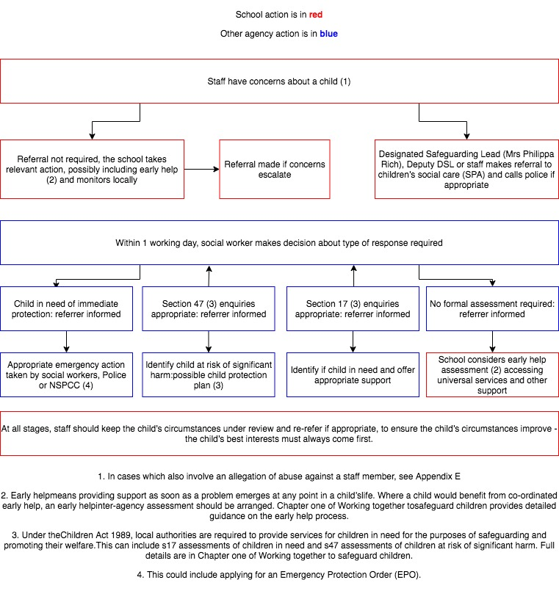

Appendix C – Procedure to be followed in the event of a disclosure

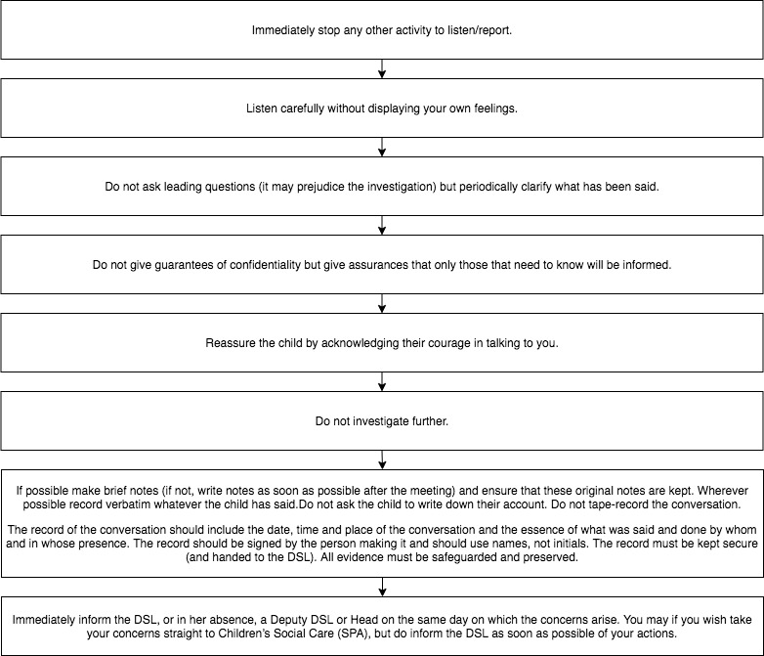

Appendix D – Procedure for reporting a concern

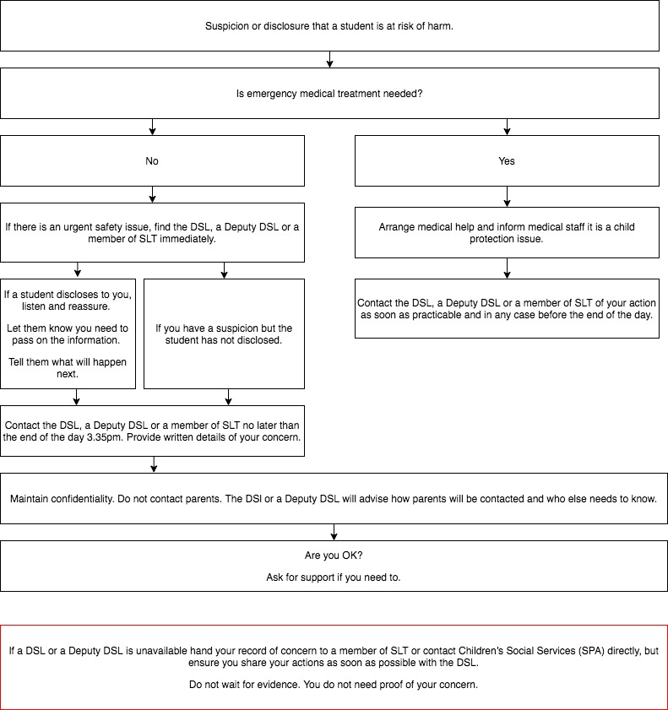

Appendix E – Allegation of abuse by a member of school staff, supply staff or volunteer (teaching or non-teaching)

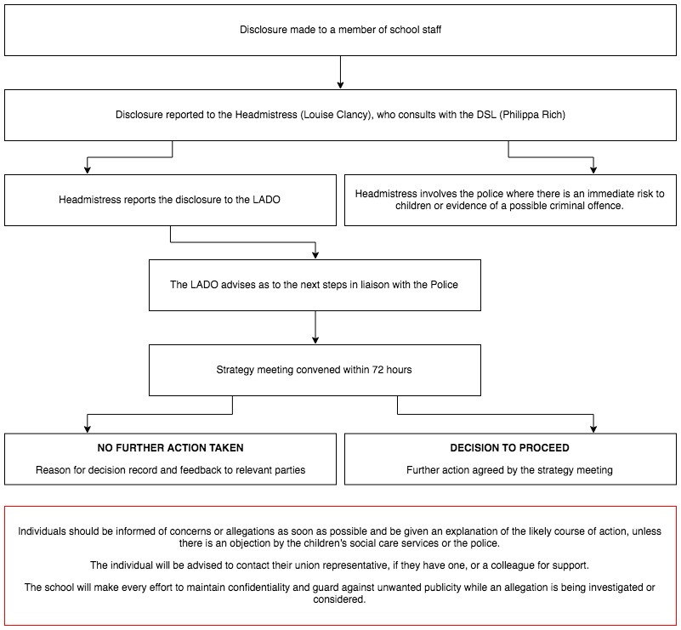

Appendix F - Referral procedure for when a child/young person discloses to a member of school staff an allegation of abuse by a Headteacher.

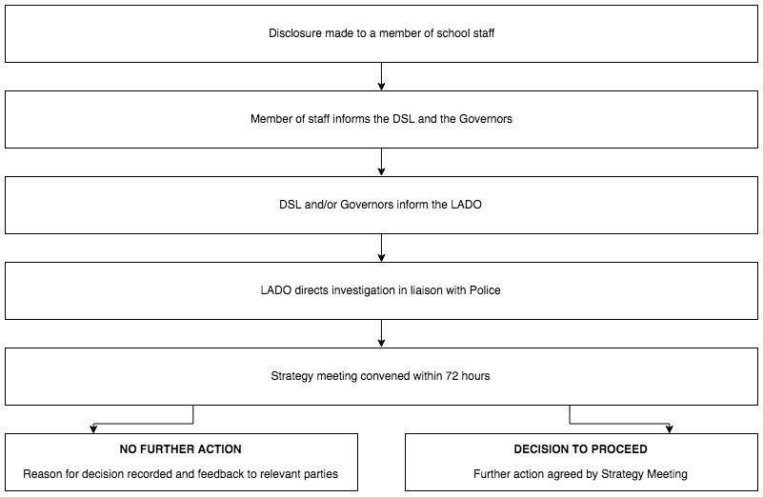

Appendix G – Procedure for referring a concern to CHANNEL

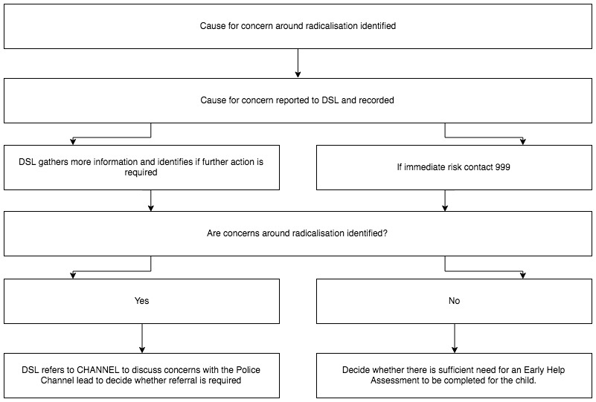

Appendix H: allegations of abuse made against staff
This section of this policy applies to all cases in which it is alleged that a current member of staff, including a supply teacher or volunteer, has:
- Behaved in a way that has harmed a child, or may have harmed a child, or
- Possibly committed a criminal offence against or related to a child, or
- Behaved towards a child or children in a way that indicates he or she may pose a risk of harm to children, or
- Behaved or may have behaved in a way that indicates they may not be suitable to work with children
It applies regardless of whether the alleged abuse took place in the school. Allegations against a teacher who is no longer teaching and historical allegations of abuse will be referred to the police.
We will deal with any allegation of abuse against a member of staff or volunteer very quickly, in a fair and consistent way that provides effective child protection while also supporting the individual who is the subject of the allegation.
Our procedures for dealing with allegations will be applied with common sense and judgement.
Suspension of the accused until the case is resolved
Suspension will not be the default position, and will only be considered in cases where there is reason to suspect that a child or other children is/are at risk of harm, or the case is so serious that it might be grounds for dismissal. In such cases, we will only suspend an individual if we have considered all other options available and there is no reasonable alternative.

Based on an assessment of risk, we will consider alternatives such as:
- Redeployment within the school so that the individual does not have direct contact with the child or children concerned
- Providing an assistant to be present when the individual has contact with children
- Redeploying the individual to alternative work in the school so that they do not have unsupervised access to children
- Moving the child or children to classes where they will not come into contact with the individual, making it clear that this is not a punishment and parents have been consulted
Definitions for outcomes of allegation investigations
- Substantiated: there is sufficient evidence to prove the allegation
- Malicious: there is sufficient evidence to disprove the allegation and there has been a deliberate act to deceive
- False: there is sufficient evidence to disprove the allegation
- Unsubstantiated: there is insufficient evidence to either prove or disprove the allegation (this does not imply guilt or innocence)
- Unfounded: to reflect cases where there is no evidence or proper basis which supports the allegation being made
Procedure for dealing with allegations
In the event of an allegation that meets the criteria above, the headteacher (or chair of governors if the headteacher is the subject of the allegation) – the ‘case manager’ – will take the following steps:
- Immediately discuss the allegation with the designated officer at the local authority. This is to consider the nature, content and context of the allegation and agree a course of action, including whether further enquiries are necessary to enable a decision on how to proceed, and whether it is necessary to involve the police and/or children’s social care services. (The case manager may, on occasion, consider it necessary to involve the police before consulting the designated officer – for example, if the accused individual is deemed to be an immediate risk to children or there is evidence of a possible criminal offence. In such cases, the case manager will notify the designated officer as soon as practicably possible after contacting the police)
- Inform the accused individual of the concerns or allegations and likely course of action as soon as possible after speaking to the designated officer (and the police or children’s social care services, where necessary). Where the police and/or children’s social care services are involved, the case manager will only share such information with the individual as has been agreed with those agencies
- Where appropriate (in the circumstances described above), carefully consider whether suspension of the individual from contact with children at the school is justified or whether alternative arrangements such as those outlined above can be put in place. Advice will be sought from the designated officer, police and/or children’s social care services, as appropriate
- If immediate suspension is considered necessary, agree and record the rationale for this with the designated officer. The record will include information about the alternatives to suspension that have been considered, and why they were rejected. Written confirmation of the suspension will be provided to the individual facing the allegation or concern within 1 working day, and the individual will be given a named contact at the school and their contact details
- If it is decided that no further action is to be taken in regard to the subject of the allegation or concern, record this decision and the justification for it and agree with the designated officer what information should be put in writing to the individual and by whom, as well as what action should follow both in respect of the individual and those who made the initial allegation
- If it is decided that further action is needed, take steps as agreed with the designated officer to initiate the appropriate action in school and/or liaise with the police and/or children’s social care services as appropriate
- Provide effective support for the individual facing the allegation or concern, including appointing a named representative to keep them informed of the progress of the case and considering what other support is appropriate.
- Inform the parents or carers of the child/children involved about the allegation as soon as possible if they do not already know (following agreement with children’s social care services and/or the police, if applicable). The case manager will also inform the parents or carers of the requirement to maintain confidentiality about any allegations made against teachers (where this applies) while investigations are ongoing. Any parent or carer who wishes to have the confidentiality restrictions removed in respect of a teacher will be advised to seek legal advice
- Keep the parents or carers of the child/children involved informed of the progress of the case and the outcome, where there is not a criminal prosecution, including the outcome of any disciplinary process (in confidence)
- Make a referral to the DBS where it is thought that the individual facing the allegation or concern has engaged in conduct that harmed or is likely to harm a child, or if the individual otherwise poses a risk of harm to a child

If the school is made aware that the secretary of state has made an interim prohibition order in respect of an individual, we will immediately suspend that individual from teaching, pending the findings of the investigation by the Teaching Regulation Agency.

Where the police are involved, wherever possible the governing board will ask the police at the start of the investigation to obtain consent from the individuals involved to share their statements and evidence for use in the school’s disciplinary process, should this be required at a later point.

Additional considerations for supply staff
If there are concerns or an allegation is made against someone not directly employed by the school, such as supply staff provided by an agency, we will take the actions below in addition to our standard procedures.
- We will not decide to stop using a supply teacher due to safeguarding concerns without finding out the facts and liaising with our local authority designated officer to determine a suitable outcome
- The governing board will discuss with the agency whether it is appropriate to suspend the supply teacher, or redeploy them to another part of the school, while the school carries out the investigation
- We will involve the agency fully, but the school will take the lead in collecting the necessary information and providing it to the local authority designated officer as required
- We will address issues such as information sharing, to ensure any previous concerns or allegations known to the agency are taken into account (we will do this, for example, as part of the allegations management meeting or by liaising directly with the agency where necessary)
When using an agency, we will inform them of our process for managing allegations, and keep them updated about our policies as necessary, and will invite the agency's HR manager or equivalent to meetings as appropriate.
Timescales
- Any cases where it is clear immediately that the allegation is unsubstantiated or malicious will be resolved within 1 week
- If the nature of an allegation does not require formal disciplinary action, we will institute appropriate action within 3 working days
- If a disciplinary hearing is required and can be held without further investigation, we will hold this within 15 working days
Specific actions
Action following a criminal investigation or prosecution
The case manager will discuss with the local authority’s designated officer whether any further action, including disciplinary action, is appropriate and, if so, how to proceed, taking into account information provided by the police and/or children’s social care services.

Conclusion of a case where the allegation is substantiated
If the allegation is substantiated and the individual is dismissed or the school ceases to use their services, or the individual resigns or otherwise ceases to provide their services, the case manager and the school’s personnel adviser will discuss with the designated officer whether to make a referral to the DBS for consideration of whether inclusion on the barred lists is required. If they think that the individual has engaged in conduct that has harmed (or is likely to harm) a child, or if they think the person otherwise poses a risk of harm to a child, they must make a referral to the DBS.

If the individual concerned is a member of teaching staff, the case manager and personnel adviser will discuss with the designated officer whether to refer the matter to the Teaching Regulation Agency to consider prohibiting the individual from teaching.

Individuals returning to work after suspension
If it is decided on the conclusion of a case that an individual who has been suspended can return to work, the case manager will consider how best to facilitate this.

The case manager will also consider how best to manage the individual’s contact with the child or children who made the allegation, if they are still attending the school.

Unsubstantiated or malicious allegations
If an allegation is shown to be deliberately invented, or malicious, the headteacher, or other appropriate person in the case of an allegation against the headteacher, will consider whether any disciplinary action is appropriate against the student(s) who made it, or whether the police should be asked to consider whether action against those who made the allegation might be appropriate, even if they are not a student.
Confidentiality
The school will make every effort to maintain confidentiality and guard against unwanted publicity while an allegation is being investigated or considered.

The case manager will take advice from the local authority’s designated officer, police and children’s social care services, as appropriate, to agree:
- Who needs to know about the allegation and what information can be shared
- How to manage speculation, leaks and gossip, including how to make parents or carers of a child/children involved aware of their obligations with respect to confidentiality
- What, if any, information can be reasonably given to the wider community to reduce speculation
- How to manage press interest if, and when, it arises
Record-keeping
The case manager will maintain clear records about any case where the allegation or concern meets the criteria above and store them on the individual’s confidential personnel file for the duration of the case. Such records will include:
- A clear and comprehensive summary of the allegation
- Details of how the allegation was followed up and resolved
- Notes of any action taken and decisions reached (and justification for these, as stated above)
If an allegation or concern is not found to have been malicious, the school will retain the records of the case on the individual’s confidential personnel file, and provide a copy to the individual.

Where records contain information about allegations of sexual abuse, we will preserve these for the Independent Inquiry into Child Sexual Abuse (IICSA), for the term of the inquiry. We will retain all other records at least until the individual has reached normal pension age, or for 10 years from the date of the allegation if that is longer.

The records of any allegation that is found to be malicious will be deleted from the individual’s personnel file.
References
When providing employer references, we will not refer to any allegation that has been proven to be false, unsubstantiated or malicious, or any history of allegations where all such allegations have been proven to be false, unsubstantiated or malicious.
Learning lessons
After any cases where the allegations are substantiated, we will review the circumstances of the case with the local authority’s designated officer to determine whether there are any improvements that we can make to the school’s procedures or practice to help prevent similar events in the future.

This will include consideration of (as applicable):
- Issues arising from the decision to suspend the member of staff
- The duration of the suspension
- Whether or not the suspension was justified
- The use of suspension when the individual is subsequently reinstated. We will consider how future investigations of a similar nature could be carried out without suspending the individual

Appendix I: Specific Safeguarding Issues
Staff should have an awareness of safeguarding issues – some of which are listed below. In addition, a number of these are mentioned in the safeguarding induction discussion and during refreshers.
Staff should be aware that behaviours linked to the likes of drug taking, alcohol abuse, deliberately missing education and sexting (also known as youth produced sexual imagery) put children in danger.

- Children in the court system
- Children missing from education, home or care
- Children with family members in prison
- Child criminal exploitation (CCE)
- Child sexual exploitation (CSE)
- County Lines
- Domestic abuse
- Drugs
- Fabricated or induced illness
- Faith abuse
- Female genital mutilation (FGM)
- Forced marriage
- Gangs and youth violence
- Gender-based violence/violence against women and girls (VAWG)
- Hate
- Homelessness
- So-called ‘honour-based’ violence
- Peer on Peer abuse (child on child)
- Radicalisation
- Relationship abuse
- Sexual violence and sexual harassment between children in schools and colleges
- Trafficking
- Upskirting

Peer on Peer/child on child abuse
In addition, all staff should be aware that safeguarding issues can manifest themselves via peer on peer abuse. Students may be harmed by other students, children or young people. Peer on peer abuse is most likely to include, but not limited to: This can include (but is not limited to): bullying (including cyberbullying); sexual violence and sexual harassment; physical abuse such as hitting, kicking, shaking, biting, hair pulling, upskirting, initiation/hazing type violence and rituals or otherwise causing physical harm; sexting and initiating/hazing type violence and rituals.

Peer on peer abuse should never be tolerated or passed off as ‘banter’, ‘just having a laugh’ or ‘part of growing up’.

Canbury actively seeks to raise awareness of and prevent all forms of peer-on-peer abuse by educating all Governors, Senior Leadership Team, staff and volunteers, students, and parents about this issue.

As a school we will minimise the risk of allegations against other students by:
- Providing a developmentally appropriate PSHE syllabus which develops students understanding of acceptable behaviour and keeping themselves safe
- Having systems in place for any student to raise concerns with staff, knowing that they will be listened to, believed and valued
- Delivering targeted work on assertiveness and keeping safe to those students identified as being at risk
- Developing robust risk assessments and providing targeted work for students identified as being a potential risk to other students
- Ensuring that all peer-on-peer abuse issues are fed back to the DSL promptly so that they can spot and address any concerning trends and identify students who may be in need of additional support. One way in which this is done is via the weekly staff meeting at which all concerns about students (including peer-on-peer abuse issues) are discussed
- Challenging the attitudes that underlie such abuse (both inside and outside the classroom)
- Engaging parents on this issue
- Working with Governors, Senior Leadership Team, all staff and volunteers, students and parents to address equality issues, to promote positive values, and to encourage a culture of tolerance and respect amongst all members of the School community
- Creating conditions in which our students can aspire to and realise safe and healthy relationships

How Canbury school deals with an allegation of peer on peer abuse is set out in section 8 of this policy.

Gender issues can be prevalent when dealing with peer on peer abuse. This could for example include girls being sexually touched/assaulted or boys being subject to initiation/hazing type violence.

Children missing from education
We will follow our procedures for unauthorised absence and for dealing with children who go missing from education, particularly on repeat occasions, to help identify the risk of abuse and neglect, including sexual exploitation, and to help prevent the risks of going missing in future. This includes informing the local authority if a child leaves the school without a new school being named, and adhering to requirements with respect to sharing information with the local authority, when applicable, when removing a child’s name from the admission register at non-standard transition points.

Staff will be trained in signs to look out for and the individual triggers to be aware of when considering the risks of potential safeguarding concerns which may be related to being missing, such as travelling to conflict zones, FGM and forced marriage.

If a staff member suspects that a child is suffering from harm or neglect, we will follow local child protection procedures, including with respect to making reasonable enquiries. We will make an immediate referral to the local authority children’s social care team, and the police, if the child is suffering or likely to suffer from harm, or in immediate danger.

Staff must be aware of the school’s ‘Child missing from education policy’.

Child criminal exploitation
Child criminal exploitation (CCE) is a form of abuse where an individual or group takes advantage of an imbalance of power to coerce, control, manipulate or deceive a child into criminal activity, in exchange for something the victim needs or wants, and/or for the financial or other advantage of the perpetrator or facilitator, and/or through violence or the threat of violence.
The abuse can be perpetrated by males or females, and children or adults. It can be a one-off occurrence or a series of incidents over time, and range from opportunistic to complex organised abuse.

The victim can be exploited even when the activity appears to be consensual. It does not always involve physical contact and can happen online. For example, young people may be forced to work in cannabis factories, coerced into moving drugs or money across the country (county lines), forced to shoplift or pickpocket, or to threaten other young people.

Indicators of CCE can include a child:
- Appearing with unexplained gifts or new possessions
- Associating with other young people involved in exploitation
- Suffering from changes in emotional wellbeing
- Misusing drugs and alcohol
- Going missing for periods of time or regularly coming home late
- Regularly missing school or education
- Not taking part in education

If a member of staff suspects CCE, they will discuss this with the DSL. The DSL will trigger the local safeguarding procedures, including a referral to the local authority’s children’s social care team and the police, if appropriate.

Child sexual exploitation (CSE)
Child sexual exploitation (CSE) is a form of abuse where an individual or group takes advantage of an imbalance of power to coerce, manipulate or deceive a child into sexual activity, in exchange for something the victim needs or wants and/or for the financial advantage or increased status of the perpetrator or facilitator. It may, or may not, be accompanied by violence or threats of violence.

The abuse can be perpetrated by males or females, and children or adults. It can be a one-off occurrence or a series of incidents over time, and range from opportunistic to complex organised abuse.

The victim can be exploited even when the activity appears to be consensual. Children or young people who are being sexually exploited may not understand that they are being abused. They often trust their abuser and may be tricked into believing they are in a loving, consensual relationship.

CSE can include both physical contact (penetrative and non-penetrative acts) and non-contact sexual activity. It can also happen online. For example, young people may be persuaded or forced to share sexually explicit images of themselves, have sexual conversations by text, or take part in sexual activities using a webcam. CSE may also occur without the victim’s immediate knowledge, for example through others copying videos or images.

Signs include:
• underage sexual activity
• inappropriate sexual or sexualised behaviour
• sexually risky behaviour, 'swapping' sex
• repeat sexually transmitted infections
• in girls, repeat pregnancy, abortions, miscarriage
• receiving unexplained gifts or gifts from unknown sources
• having multiple mobile phones and worrying about losing contact via mobile
• having unaffordable new things (clothes, mobile) or expensive habits (alcohol, drugs)
• changes in the way they dress
• going to hotels or other unusual locations to meet friends
• seen at known places of concern
• moving around the country, appearing in new towns or cities, not knowing where they are
• getting in/out of different cars driven by unknown adults
• having older boyfriends or girlfriends
• contact with known perpetrators
• involved in abusive relationships, intimidated and fearful of certain people or situations
• hanging out with groups of older people, or anti-social groups, or with other vulnerable peers
• associating with other young people involved in sexual exploitation
• recruiting other young people to exploitative situations
• truancy, exclusion, disengagement with school, opting out of education altogether
• unexplained changes in behaviour or personality (chaotic, aggressive, sexual)
• mood swings, volatile behaviour, emotional distress
• self-harming, suicidal thoughts, suicide attempts, overdosing, eating disorders
• drug or alcohol misuse
• getting involved in crime
• police involvement, police records
• involved in gangs, gang fights, gang membership
• injuries from physical assault, physical restraint, sexual assault.

If a member of staff suspects CSE, they will discuss this with the DSL. The DSL will trigger the local safeguarding procedures, including a referral to the local authority’s children’s social care team and the police, if appropriate.

Domestic Abuse
The definition of domestic violence and abuse is – any incident or pattern of incidents of controlling, coercive, threatening behaviour, violence or abuse between those aged 16 or over who are, or have been, intimate partners or family members regardless of gender or sexuality. The abuse can encompass, but is not limited to:
- Psychological
- Physical
- Sexual
- Financial
- Emotional

All children can witness and be adversely affected by domestic abuse in the context of their home life where domestic abuse occurs between family members. In some cases, a child may blame themselves for the abuse or may have had to leave the family home as a result.
Older children may also experience domestic abuse and/or violence in their own personal relationships.
Exposure to domestic abuse and/or violence can have a serious, long-lasting emotional and psychological impact on children.
The DSL will provide support according to the child’s needs and update records about their circumstances.

Female Genital Mutilation (FGM)
The DSL will make sure that staff have access to appropriate training to equip them to be alert to children affected by FGM or at risk of FGM.
Section 8 of this policy sets out the procedures to be followed if a staff member discovers that an act of FGM appears to have been carried out or suspects that a student is at risk of FGM.
Indicators that FGM has already occurred include:
- A student confiding in a professional that FGM has taken place
- A mother/family member disclosing that FGM has been carried out
- A family/student already being known to social services in relation to other safeguarding issues
- A girl:
  - Having difficulty walking, sitting or standing, or looking uncomfortable
  - Finding it hard to sit still for long periods of time (where this was not a problem previously)
  - Spending longer than normal in the bathroom or toilet due to difficulties urinating
  - Having frequent urinary, menstrual or stomach problems
  - Avoiding physical exercise or missing PE
  - Being repeatedly absent from school, or absent for a prolonged period
  - Demonstrating increased emotional and psychological needs – for example, withdrawal or depression, or significant change in behaviour
  - Being reluctant to undergo any medical examinations
  - Asking for help, but not being explicit about the problem
  - Talking about pain or discomfort between her legs
Potential signs that a student may be at risk of FGM include:
- The girl’s family having a history of practising FGM (this is the biggest risk factor to consider)
- FGM being known to be practised in the girl’s community or country of origin
- A parent or family member expressing concern that FGM may be carried out
- A family not engaging with professionals (health, education or other) or already being known to social care in relation to other safeguarding issues
- A girl:
  - Having a mother, older sibling or cousin who has undergone FGM
  - Having limited level of integration within UK society
  - Confiding to a professional that she is to have a “special procedure” or to attend a special occasion to “become a woman”
  - Talking about a long holiday to her country of origin or another country where the practice is prevalent, or parents stating that they or a relative will take the girl out of the country for a prolonged period
  - Requesting help from a teacher or another adult because she is aware or suspects that she is at immediate risk of FGM
  - Talking about FGM in conversation – for example, a girl may tell other children about it (although it is important to take into account the context of the discussion)
  - Being unexpectedly absent from school
  - Having sections missing from her ‘red book’ (child health record) and/or attending a travel clinic or equivalent for vaccinations/anti-malarial medication
The above indicators and risk factors are not intended to be exhaustive.

Forced marriage
Forcing a person into marriage is a crime. A forced marriage is one entered into without the full and free consent of one or both parties and where violence, threats, or any other form of coercion is used to cause a person to enter into a marriage. Threats can be physical or emotional and psychological.
A lack of full and free consent can be where a person does not consent or where they cannot consent (if they have learning disabilities, for example). Nevertheless, some communities use religion and culture as a way to coerce a person into marriage.

Staff will receive training around forced marriage and the presenting symptoms. We are aware of the ‘one chance’ rule, i.e. we may only have one chance to speak to the potential victim and only one chance to save them.
If a member of staff suspects that a student is being forced into marriage, they will speak to the student about their concerns in a secure and private place. They will then report this to the DSL.
The DSL will:
- Speak to the student about the concerns in a secure and private place
- Activate the local safeguarding procedures and refer the case to the local authority’s designated officer
- Seek advice from the Forced Marriage Unit on 020 7008 0151 or fmu@fco.gov.uk
Refer the student to the Mental Health Lead, tutor, ELSA, Pastoral Deputy Head as appropriate.

Homelessness
Being homeless or being at risk of becoming homeless presents a real risk to a child’s welfare.
The DSL and deputies will be aware of contact details and referral routes in to the local housing authority so they can raise/progress concerns at the earliest opportunity (where appropriate and in accordance with local procedures).

Where a child has been harmed or is at risk of harm, the DSL will also make a referral to children’s social care.

Preventing radicalisation
- Radicalisation refers to the process by which a person comes to support terrorism and extremist ideologies associated with terrorist groups

- Extremism is vocal or active opposition to fundamental British values, such as democracy, the rule of law, individual liberty, and mutual respect and tolerance of different faiths and beliefs. This also includes calling for the death of members of the armed forces

- Terrorism is an action that:
  - Endangers or causes serious violence to a person/people;
  - Causes serious damage to property; or
  - Seriously interferes or disrupts an electronic system

The use or threat of terrorism must be designed to influence the government or to intimidate the public and is made for the purpose of advancing a political, religious or ideological cause.

Schools have a duty to prevent children from being drawn into terrorism. The DSL will undertake Prevent awareness training and make sure that staff have access to appropriate training to equip them to identify children at risk.

We will assess the risk of children in our school being drawn into terrorism. This assessment will be based on an understanding of the potential risk in our local area, in collaboration with our local safeguarding partners and local police force.

We will ensure that suitable internet filtering is in place, and equip our students to stay safe online at school and at home.

There is no single way of identifying an individual who is likely to be susceptible to an extremist ideology. Radicalisation can occur quickly or over a long period.

Staff will be alert to changes in students’ behaviour.

The government website Educate Against Hate and charity NSPCC say that signs that a student is being radicalised can include:
- Refusal to engage with, or becoming abusive to, peers who are different from themselves
- Becoming susceptible to conspiracy theories and feelings of persecution
- Changes in friendship groups and appearance
- Rejecting activities they used to enjoy
- Converting to a new religion
- Isolating themselves from family and friends
- Talking as if from a scripted speech
- An unwillingness or inability to discuss their views
- A sudden disrespectful attitude towards others
- Increased levels of anger
- Increased secretiveness, especially around internet use
- Expressions of sympathy for extremist ideologies and groups, or justification of their actions
- Accessing extremist material online, including on Facebook or Twitter
- Possessing extremist literature
- Being in contact with extremist recruiters and joining, or seeking to join, extremist organisations
Children who are at risk of radicalisation may have low self-esteem, or be victims of bullying or discrimination. It is important to note that these signs can also be part of normal teenage behaviour – staff should have confidence in their instincts and seek advice if something feels wrong.

If staff are concerned about a student, they will follow our procedures set out in section 8 of this policy, including discussing their concerns with the DSL.

Staff should always take action if they are worried.

Further information on the school’s measures to prevent radicalisation are set out in other school policies and procedures, including: PREVENT and Upholding British Values Policy.

Serious Violence
All staff should be aware of indicators, which may signal that children are at risk from, or are involved with serious violent crime. These may include:
- Increased absence from school
- A change of friendships or relationships with older individuals or groups
- A significant decline in performace
- Signs of self harm or significant change in wellbeing
- Signs of assult or unexplained injuries
- Unexplained gifts or new possessions.

So-called ‘honour-based’ abuse (including FGM and forced marriage)
So-called ‘honour-based’ abuse (HBA) encompasses incidents or crimes committed to protect or defend the honour of the family and/or community, including FGM, forced marriage, and practices such as breast ironing.

Abuse committed in this context often involves a wider network of family or community pressure and can include multiple perpetrators.

All forms of HBA are abuse and will be handled and escalated as such. All staff will be alert to the possibility of a child being at risk of HBA or already having suffered it. If staff have a concern, they will speak to the DSL, who will activate local safeguarding procedures.

Sexual violence
It is important that staff are aware of sexual violence and the fact children can, and sometimes do, abuse their peers in this way. When referring to sexual violence we are referring to sexual offences under the Sexual Offences Act 2003105 as described below:
  - Rape: A person (A) commits an offence of rape if: he intentionally penetrates the vagina, anus or mouth of another person (B) with his penis, B does not consent to the penetration and A does not reasonably believe that B consents.
  - Assault by Penetration: A person (A) commits an offence if: s/he intentionally penetrates the vagina or anus of another person (B) with a part of her/his body or anything else, the penetration is sexual, B does not consent to the penetration and A does not reasonably believe that B consents.
  - Sexual Assault: A person (A) commits an offence of sexual assault if: s/he intentionally touches another person (B), the touching is sexual, B does not consent to the touching and A does not reasonably believe that B consents.

Consent is about having the freedom and capacity to choose. Consent to sexual activity may be given to one sort of sexual activity but not another, e.g. to vaginal but not anal sex or penetration with conditions, such as wearing a condom. Consent can be withdrawn at any time during sexual activity and each time activity occurs. Someone consents to vaginal, anal or oral penetration only if s/he agrees by choice to that penetration and has the freedom and capacity to make that choice.

Sexual harassment
When referring to sexual harassment we mean ‘unwanted conduct of a sexual nature’ that can occur online and offline. When we reference sexual harassment, we do so in the context of child on child sexual harassment. Sexual harassment is likely to: violate a child’s dignity, and/or make them feel intimidated, degraded or humiliated and/or create a hostile, offensive or sexualised environment.

Whilst not intended to be an exhaustive list, sexual harassment can include:
- sexual comments, such as: telling sexual stories, making lewd comments, making sexual remarks about clothes and appearance and calling someone sexualised names;
- sexual “jokes” or taunting;
- physical behaviour, such as: deliberately brushing against someone, interfering with someone’s clothes (we should be considering when any of this crosses a line into sexual violence - it is important to talk to and consider the experience of the victim) and displaying pictures, photos or drawings of a sexual nature;
- upskirting;
- online sexual harassment, which might include: non-consensual sharing of sexual images and videos and sharing sexual images and videos (see Youth produced sexual imagery (Sexting) p. 8i); unwanted sexual comments on social media; sexualised online bullying; exploitation; coercion and threats. Online sexual harassment may be stand alone, or part of a wider pattern of sexual harassment and/or sexual violence

School related weapons incidents
We follow the ‘AfC School Related Weapons or Potential Weapons Incidents’ Protocol and have a duty and a responsibility to protect and safeguard our students and staff. We will inform SPA and the police of any incident involving a weapon or potential weapon.

Teachers have a number of legal powers which include the power to search pupils without consent for a number of ‘prohibited items’. These include: knives and weapons; alcohol; illegal drugs and stolen items; tobacco and cigarette papers; fireworks; pornographic images; any article that the member of staff reasonably suspects has been, or is likely to be, used to commit an offence, cause personal injury or damage to property; and any item banned by the school rules that has been identified in these rules as an item that may be searched for searching, screening and confiscation

Canbury School recognises that children and young people involved in school related weapons incidents, including the alleged perpetrators, are vulnerable. We will provide support, protection and education to develop a full understanding of the implications of carrying, and or using, weapons.

See further guidance on Searching, screening and confiscation please see our ‘Searching and Confiscation Procedure’

Upskirting
The Voyeurism (Offences) Act, which is commonly known as the Upskirting Act came in to force on 12th April 2019. ‘Upskirting’ typically involves taking a picture under a person’s clothing without them knowing, with the intention of viewing their genitals or buttocks to obtain sexual gratification, or cause the victim humiliation, distress or alarm. It is now a criminal offence. Anyone of any gender, can be a victim.

See further guidance on responding to reports of sexual violence or sexual harassment in section 8 of this policy.

Appendix J: Checking the identity and suitability of visitors
All visitors will be required to verify their identity to the satisfaction of staff and to leave their belongings, including their mobile phone(s), in a safe place during their visit.

If the visitor is unknown to the setting, we will check their credentials and reason for visiting before allowing them to enter the setting. Visitors should be ready to produce identification.

Visitors are expected to sign the visitors’ book and wear a visitor’s badge.

Visitors to the school who are visiting for a professional purpose, such as educational psychologists and school improvement officers, will be asked to show photo ID and:
- Will be asked to show their DBS certificate, which will be checked alongside their photo ID; or
- The organisation sending the professional, such as the LA or educational psychology service, will provide prior written confirmation that an enhanced DBS check with barred list information has been carried out
All other visitors, including visiting speakers, will be accompanied by a member of staff at all times. We will not invite into the school any speaker who is known to disseminate extremist views, and will carry out appropriate checks to ensure that any individual or organisation using school facilities is not seeking to disseminate extremist views or radicalise students or staff.

Appendix K: Non-collection of children and Missing Students
Refer to the ‘Child Missing Education Policy and Procedures’ for further details.

Appendix J: Safer Recruitment
Refer to the ‘Recruitment, Selection and Disclosures Policy and Procedure’ for further details.

