CANBURY SCHOOL
Student Behaviour, Sanctions and Rewards Policy

Introduction
Canbury School aims to encourage students to adopt the highest standards of behaviour, principles and morals. We aim to promote trust and mutual respect for everyone. We believe that good relations, good manners and a secure learning environment play a crucial part in the development of intellectually curious students, who are motivated to become lifelong learners.
Canbury School is an inclusive community. We welcome students from a wide variety of ethnic and social backgrounds and faiths. We treat everyone as an individual and aim to develop the whole person equipped to take his/her place in the modern world.

Expectations of Students
We expect students to treat staff and each other with consideration and good manners and to respond positively to the opportunities and demands of school life. Canbury school expects its students to adhere to a code of conduct - “The Canbury Code”, (see Appendix 1) rather than to a list of rules.

Everyone has a right to feel secure and to be treated with respect, particularly the vulnerable. Harassment and bullying will not be tolerated. The school is strongly committed to promoting equal opportunities for all, regardless of race, religion, gender, sexual orientation or physical disability. We expect students to behave at all times in a manner that reflects the best interests of the whole community.

Expectations of Staff
Staff are committed to excellence, aiming to achieve a spirit of trust and co-operation. We expect the highest values and standards of behaviour inside and outside the classroom, as well as outside the school and in any written or electronic communication concerning the school.

Expectations of Parents/Guardians
Parents and Guardians who accept a place for their child at Canbury School undertake to uphold the school’s policies and regulations, including this policy.
They will support the school’s values in matters such as attendance and punctuality, behaviour, uniform and appearance, standards of academic work, extra-curricular activities and homework.
We will always telephone the home on the first day of an unexplained absence in order to make sure of your child’s safety. Please note that it is the policy of this school usually, not to allow holiday to be taken during term.

Sanctions

Minor Incidents
Work not done or late, late to lessons, disruptive or silly behaviour in lessons should be dealt with by the subject teacher. Minor incidents - such as inconsiderate behaviour towards other students or staff, should be dealt with at the time by all members of staff. Persistent offenders - staff should enter details and action taken onto the student’s record on RMIntergris, and notify SLT staff by email.

Serious Incidents
Serious use of bad language, inappropriate behaviour towards other students should be referred to the Pastoral Assistant Head immediately and the Headmistress if necessary.

3 Step Warning System
In the case of a minor incident staff should follow the 3 step warning system set out below:

Step 1
Issue a quiet reminder of the rule being broken
e.g. ‘As it states in our behaviour policy, I am now issuing you with a reminder that you are breaking … rule’ (point/refer to the poster in your classroom).

Step 2
Name on board and a formal warning.
Reminder of the rule being broken.
e.g. ‘As it states in our behaviour policy, I am now issuing you with a formal warning for your behaviour and breaking … rule’ (point/refer to the poster in your classroom) and put the students name on the board.

Step 3
Final warning issued and supportive action taken.
Reminder of the rule being broken.
Supportive action taken e.g. moved to another seat, red card placed on desk (visual cue), 5min time out from class or mark next to name on board.
e.g. ‘As it states in our behaviour policy, I am now issuing you with a final warning for your behaviour and breaking … rule (point/refer to the poster in your classroom).
I am taking supportive action by… (one of the above actions).

Further non-compliance within the classroom leads to:
- 15 minute detention
- Staff member involved contacts home either via email or phone call
- Information recorded on the students record RMIntergris, and SLT informed.

If the student still does not comply with behaviour expectations, then the student should be removed from the classroom (see Exclusion from the classroom below for more details).

Short Detention
- A detention of 15 minutes after school or at lunchtime can be given by any member of staff for any minor offence
- The detention normally runs on the day of the offence, unless this presents an insurmountable problem, in which case it must take place on the following day
- After school short detention runs from 3.35 – 3.50 p.m. and no parental notification needs to be given
- Detainees may be asked to clean desks, recover rubbish or any other similar tasks
- Staff giving this type of detention must also supervise it.

One Hour Detentions
- A detention of one hour is given for any serious offences
- It can take place after school 3.35 – 4.35 p.m. supervised by the duty SLT who should be informed of the detention and the task/work to be completed
- A standard letter is produced as an email attachment by reception and sent home - it should provide details of the offence and should specify the date of the detention
- Work must be set by the member of staff involved and should NOT be homework, unless the detention is caused by an academic problem.

Any detention given must be noted on RMIntergris.

If a student is late to school without good reason, they can be placed in a SLT break time detention on the same day.

Canbury School does not use or threaten to use corporal punishment.

Recording Procedure for Serious Incidents
All staff should enter details and school action on the student’s record on RMIntergris which will automatically notify the student’s form tutor.

RMIntergris negative behavior logs must include:
- Behavior type shown
- Date
- Staff member name reporting the incident
- If the incident is open or closed (open = still requiring details to be input or requires further investigation, Closed = behaviour has been fully investigated and resolved)
- The details of the incident
- The action taken
- The details of the action taken

RMIntergris forms part of a system to monitor student behaviour/performance. It must be monitored regularly by form tutors and the Pastoral Assistant Head. Students who continue to collect incidents will be put on report and/or have other support structures put in place.

Exclusion from the classroom
If you find the behaviour of any student in the classroom unacceptable they must be referred to Ms Clancy. If Ms Clancy is not in school, the student will be redirected to Mrs Rich or Mrs Branney. The Student must report to reception who will deal with finding the member of staff.

Physical Violence
Any report of physical violence will be investigated by the Pastoral Assistant Head, who must involve/inform the form tutor and Headmistress immediately. After a full investigation, the Headmistress will agree the action to be taken. In the absence of the Headmistress at the time of the incident or reporting of the incident, it is likely that all involved parties may be removed from school until the matter may be resolved. Parents are likely to be involved in the process and should any suspension result, parents will be brought in to discuss the issue and agree a procedure.

Reasonable adjustments for students with SEND
In accordance with the Equalities Act 2010, the school acknowledges its legal duties in respect of safeguarding and special educational needs. Particular consideration will be given to those students with special educational needs or disability when considering behaviour, discipline and sanctions. The school will take account of any special educational needs when considering whether or not to exclude a student. Students will not be treated less favorably for reasons related to the disability and steps will be taken to ensure this. Steps could include differentiation of the school’s behaviour policy, behaviour modification strategies and requesting external help with the student. Adjustments will be made according to the student’s specific needs.

Malicious accusations against staff
If an allegation is determined to be unfounded, the school will refer the matter to Children’s Social Care to decide whether the student concerned needs services or support. Malicious accusations against our staff are not acceptable and are taken very seriously. Canbury School takes disciplinary action against students who are found to have made malicious accusations against staff which if necessary, may include exclusions.

Suspensions and Exclusions
The Headmistress may suspend or exclude a Student without necessarily giving reasons, for the good of the student or the school. However, it is expected that the Chairman of Governors would be informed.

The School aims to operate by consent and not by imposition. If that consent is not forthcoming, in the last resort the School may permanently exclude a student. The decision on exclusion is the Head’s.

Verbal and written warnings would be given and ongoing discussion would always occur before such drastic action was taken unless it was a case of a single unacceptable action by the student. Even in such a case, the School having found that the student is liable to be excluded, discussion with parents and teachers would always take place before a final decision was taken. The decision is the Head’s. The Chair of Governors would be informed. In addition to the above, each situation would be considered on an individual basis taking in to consideration any SEND and/or emotional need of the student.

For example, a student may be excluded from Canbury:

  - If the student continues to break School rules (The Canbury Code) after warnings and previous punishments;

  - If the student is not prepared to accept School sanctions such as detentions;

  - If the student brings into the School (or takes at School) illegal drugs or alcohol;

  - If the student is a danger to other students or staff; including physical assault or threatening behaviour;

  - If the student personally disrupts lessons so that other students cannot learn;

  - If the student is a bad influence on other students;

  - If the student is grossly rude to member of staff or other employees of the School;

  - If all relevant facts are not disclosed on entry to the School;

  - If the student does not adhere to the anti-bullying policy including cyber-bullying;

  - For theft, sexual harassment, racist abuse, disability abuse, sexual misconduct and damage to property.

  - If a student has been found to have committed a criminal offence in or outside school or found to have behaved in a manner that tends to bring the School into disrepute.

This list of examples is not exhaustive.

If parents, after consultation, still disagree with the decision to exclude the student they should write to:
The Chair of the Governors
Canbury School
Kingston Hill
Kingston upon Thames
Surrey
KT2 7LN

The Appeals Committee of Governors would be convened to hear their concerns. The student and his/her parents/guardians may, if they wish, be accompanied to the hearing by one “friend”. The Committee would either confirm the decision on exclusion or reinstate the student having suggested alternative sanctions. The Committee’s decision would be final.

Support Structures for Students Causing Concern
The following structures exist within the school to support students whose behaviour is causing concern. Referral to these areas of support can be via the Assistant Heads and in all cases parental involvement is essential.

Mentoring Scheme
A team of mentors works within the school to support and encourage students who are not achieving their potential.

Placement on the SEND Register
Students on the register are monitored by either the Academic or Pastoral Assistant Head and appropriate interventions are put in place.

Student Support Plans
These plans are for students who are failing to uphold the Canbury Code on a regular basis. Students are set targets and the school’s interventions are stated.

Report
Students may be placed on report by their form tutor or a member of SLT after concerns have been raised. This is monitored by the staff member issuing the report to the student. Parents are usually involved in monitoring of the report and feedback is sent to parents by the school.

In addition to the above structures that can be put into place within the school setting the school may liaise with outside agencies, such as Educational Psychologists, CAMHS, counselling services and the SPA team, where appropriate.

Rewards
At Canbury School, we encourage the establishment of good teacher/student relationships and support for the school’s values through a system of rewards and sanctions which are designed to promote a calm, disciplined learning environment.

Our system of rewards includes:

Departmental
To recognise achievement within departments students may receive stamps, stickers, postcards home, verbal praise or a call/email home.

House Points
All students are placed in to one of three houses within the school (Johnson, Noble and Campbell) and can earn points for both themselves and their house. House points can be awarded for (but not limited to) displaying positive attitude to learning, progress and achievement and helpfulness around school. Students are issued with House points via RMIntergris and their Proud of Canbury Cards.
At the end of each half term the house points are totaled up and the house with the most points receives a ‘house party’.

Key Stage 3
Star Awards
House points also count towards student’s own personal awards. Students start collecting their ‘Star Awards’, which follow the following sequence:
- Blue award – 15
- Green award – 30
- Purple award – 45
- Bronze award – 60
- Silver award – 75
- Gold award – 100

Achiever Awards
Once a student has received their gold star award they begin to work on gaining their Achiever Awards. The awards follow the following sequence:
- Silver/Blue – 150
- Gold/Green – 200
- Gold/Red – 250
- Gold/Yellow – 300

Once each level has been reached students must inform the Pastoral Assistant Head who will ensure that the pin badge, raffle tickets and certificate is given out by the headmistress in the next whole school assembly.

Key Stage 4
Letter Home
As with the Key Stage 3 house points are collected. Students are working towards praise letters home from the pastoral assistant head and additional raffle tickets for the prize draw.

Head Teacher Commendation
Once students have reached 100 house points they will begin to work towards gaining their head teachers commendations. These will involve praise letters home from the head teacher and raffle tickets.

Key Stage 3 and 4
Head teacher’s Award
Once a student has received 300 House points they begin to work on gaining their Head teacher’s awards. The awards follow the following sequence:
• Bronze Head teacher’s Award 400
• Silver Head teacher’s Award 600
• Gold Head teacher’s Award 1000

Raffle Ticket Prize Draw
At the end of each term one raffle ticket is drawn and the winner will receive a £50 Amazon gift voucher.

Reward Assemblies
These are held at the day of term during the autumn and spring term, during which the following is recognised/presented:
- House rewards
- Attendance awards

Prize Giving Assembly
This is held on the last day of term in the summer term, during which the following is recognised/presented:
- Departmental effort and academic awards
- Sporting awards
- House cups
- School cups
- Head teacher awards
- Attendance awards

Managing Pupil Transition
We carefully manage the transition of the students through the Key Stages. At the beginning of each year the whole student body is discussed at a staff meeting and strategies discussed for the coming year, students are also discussed in the weekly staff and LSA meetings. Good communication between staff is vital so that any specific student support systems or strategies are applied by all and integrated into the school day to ensure consistency in their behavior management.

We are especially careful in ensuring that transitions for children with SEND are fully prepared at all stages of their school career.

Prior to starting at Canbury school children can participate in welcome mornings and taster days to enable them to feel prepared for the academic transition of moving to secondary school, but also the social side.

Appendix 1:
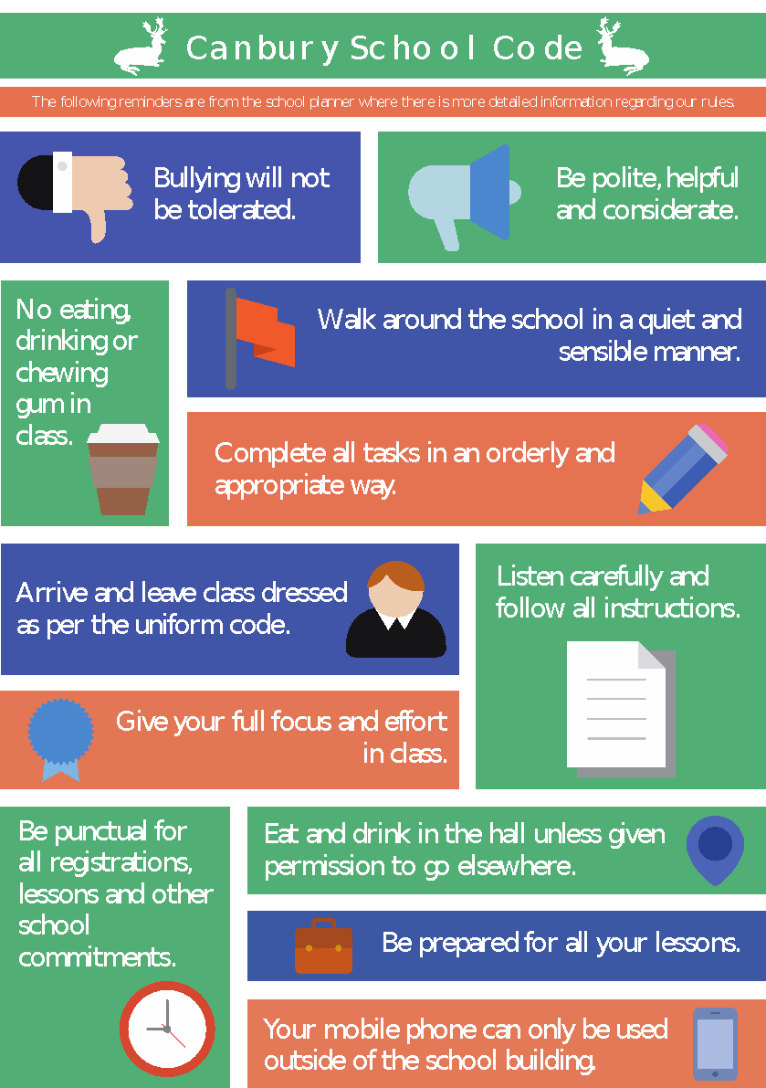

Appendix 2:

Dear ……………..

I regret to inform you that ………… has been placed in a one hour detention with ……………… (SLT Name).
Date of detention:
Teacher name:
Venue:
Reason:
Please acknowledge by email to the named member of staff below that you have received this notification and agree to the detention on the date stated.

Kind regards

(Staff Name)

…………………………………………………………………

